**7. NATO Missile System.**

**Stinger Weapon System**

***7.1. Introduction***

The Stinger weapon system is a man portable (34.5 pounds), shoulder-fired, supersonic missile system designed to counter high-speed, low-level, ground attack aircraft. Stinger is effective against helicopters, unmanned aerial vehicles, and observation and transport aircraft. Once fired, Stinger uses proportional navigation

algorithms to guide the missile to a predicted intercept point. The Stinger missile can be used as a man portable air defense system (MANPAD) when the weapon is fired from the gunner’s shoulder, mounted aboard the Avenger weapons system, or mounted in the light armored vehicle-air defense variant (LAV-AD).

Stinger reprogrammable microprocessor (RMP) (the Stinger missile’s most recent variant) is a dual-channel, passive infrared (IR) and ultraviolet (UV) tracking seeker and proportional navigational guidance missile system. The spectral discrimination of the seeker detector material, when supercooled by the argon gas in the battery coolant unit, enables Stinger to acquire, track, and engage targets in any aspect (incoming, outgoing, or crossing). Stinger is a true “fire and forget” missile, requiring no inputs from the gunner once the weapon is fired. This allows the gunner to take cover, move to an alternate position, or engage additional targets. Stinger also possesses an integral identification, friend or foe (IFF) subsystem to assist the gunner in identifying friendly aircraft. The Stinger missile is comprised of the guidance, tail, propulsion, and warhead sections. The tail assembly consists of four folding tail fins that provide roll and stability while the missile is in flight (Figure 1).

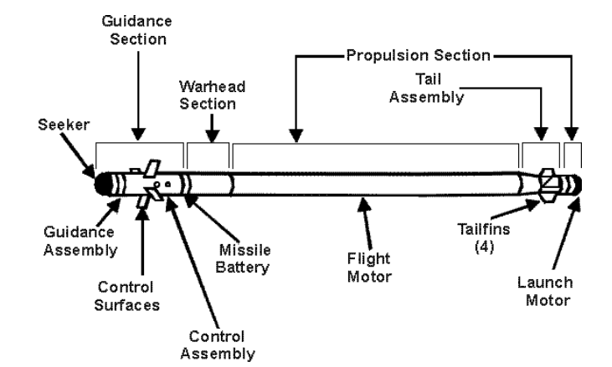

**Fig. 1** Stinger Missile

The *guidance section* consists of a seeker assembly, a guidance assembly, a control assembly, a missile battery, and four control surfaces (or wings) that provide in-flight manoeuvrability.

The *warhead section* consists of a fuze assembly and the equivalent of one pound of high explosives encased in a pyrophoric titanium cylinder. The fuze is extremely safe and makes the missile exempt from any hazards of electromagnetic radiation to ordnance conditions. The warhead can be detonated by penetrating the target, impacting the target, or self-destruction. Self-destruction occurs 15 to 19 seconds after launch.

The *propulsion section* consists of a launch motor and a dual-thrust flight motor. The launch motor ejects the missile from the launch tube. The missile coasts a safe distance (about 9 meters) from the gunner before the dual thrust flight motor ignites and provides a sustained 22 gravity acceleration that arms the missile. After the gunner arms the missile, a sustained flight phase maintains missile velocity until the propellant is consumed. Then the missile enters a free flight period in which the motor has burned out, but the missile maintains a degree of maneuverability prior to interception or selfdestruction.

***7.2. System architecture***

The Stinger weapon round (Figure 2) is shipped from the ammunition supply point in a crush resistant, hardened, reusable aluminum box. It is certified for immediate firing. This box is called the weapon round container, but is more commonly referred to as a mono box. Stinger rounds are packaged in a thin, wood-sided box surrounding a foam insert in which the missile is packed. The boxes are known as “lettuce crates” because of their similarity to produce boxes. The Stinger weapon round consists of a missile round, a separable gripstock assembly, and up to three battery coolant units (BCUs). The gripstocks are shipped separately from the missile to enhance security during shipping.

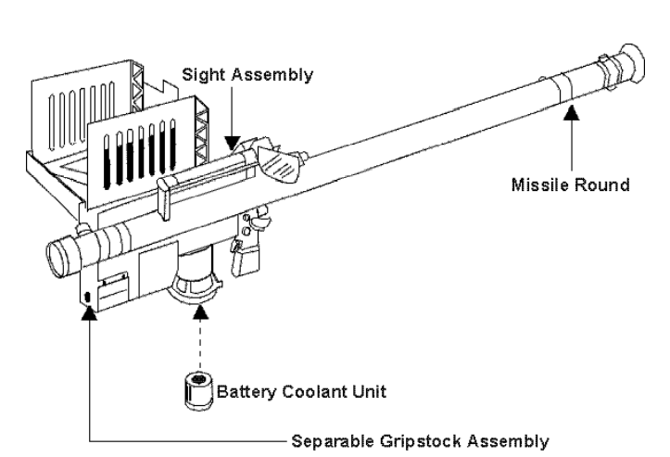

**Fig. 2** Stinger Weapon Round

The *missile round* consists of a Stinger missile sealed in a launch tube with an attached sight assembly. The sight assembly allows the gunner to range and track an aircraft. Two acquisition indicators are mounted on the sight assembly. The first, a speaker, allows the gunner to hear the IR acquisition signal and IFF tones when interrogations are made through the IFF subsystem. The second indicator is a bone transducer that allows the gunner to “feel” the IR acquisition signal on the cheekbone. Also attached to the sight is a clear plastic eye shield that protects the gunner’s left eye when the missile is fired.

The *gripstock* consists of the gripstock assembly and the IFF antenna assembly. The gripstock assembly contains all of the circuits and components required to prepare and launch the missile as well as the interface for the IFF subsystem. The gripstock is of a clamshell design so that internal components and circuitry within the gripstock can be serviced by qualified technicians at depot-level maintenance. After the missile is launched, the gripstock is removed from the launch tube for attachment to a missile round.

When the IFF antenna assembly is unfolded and the IFF interrogator is connected to the weapon, the gunner can interrogate aircraft and receive coded replies. The gripstock also houses the auxiliary unit interface, where the reprogrammable microprocessor read-only memory (ROM) module is located. It is accessed through an interface connector cover on the left side of the gripstock. The read-only memory module provides not only additional capability, but built-in economy into the Stinger missile program as a whole. Since the missile is fully digital, the ROM module allows for advanced guidance and tracking technology to be added to the missile without purchasing new missiles. Advanced counter-countermeasure technology can update current missiles in the same manner. The read-only memory interface allows technicians to access the electronics section and install the updated modules into the missiles.

The *battery coolant unit* contains a thermal battery that provides power for pre-flight system operations and a supply of argon gas to cool the IR detector in the missile seeker. Once activated, the BCU supplies electrical power and seeker coolant until the missile is launched or for a maximum of 45 seconds. The battery coolant unit is removed from the gripstock BCU well and discarded immediately after use.

***7.3. IFF Subsystem***

The identification, friend or foe subsystem allows the gunner to electronically interrogate an aircraft to determine if the aircraft is a friend, possible friend, or unknown (Figure 3). The IFF subsystem notifies the gunner of the results of an interrogation using a sequence of audible tones. Once the gunner issues an IFF challenge, the remainder of the sequence is automatic. The IFF subsystem does not identify hostile aircraft or prevent Stinger from firing at friendly aircraft.

The identification, friend or foe subsystem is coded in either a complex, cryptographic secure form (Mode IV) or a simpler form (Mode III). All United States combat aircraft are equipped with transponders to provide Mode III and Mode IV replies; however, some aircraft, including commercial and allied nation aircraft, can only provide Mode III replies. Since Mode IV is secure, a friendly Mode IV reply is considered a “true friend” reply. A Mode III reply is considered an “unknown” reply.

A Stinger’s IFF response or lack of response does not constitute authority to fire on a target. IFF responses merely assist gunners in determining the true nature of a target. Weapons control statuses, identification criteria, and rules of engagement for the operation provide the guidelines for identification and engagement of targets.

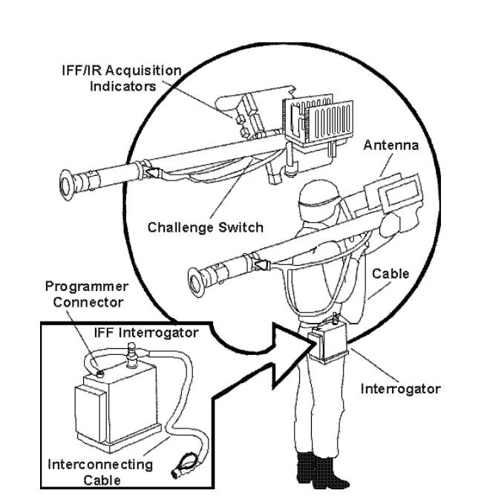 **Fig. 3** IFF Subsystem

The interrogator can be programmed to operate in Mode IV only, or simultaneously in Mode III and Mode IV. It can operate in Mode IV for 2 days, operating on two sets of IFF Mode IV codes, without being recharged or reprogrammed. Within 2 days, a recharged battery should be installed and the unit reprogrammed. Unless reprogrammed, the system automatically shifts from Mode IV to Mode III. It remains in Mode III until batteries are discharged or the system is reprogrammed. Before an IFF interrogator is reprogrammed, a freshly charged battery pack should be inserted. Battery packs should be charged for a minimum of 4 hours. A fully charged battery normally provides for approximately 800 interrogations or 30 days of battery power before requiring recharge.

Programmer or battery chargers, code input computers, shipping and storage containers, and key codes support the IFF subsystem. This equipment is located at the firing section headquarters. Each firing section has 10 IFF interrogators. Unit standing operating procedures specify distribution of interrogators between firing teams and the section headquarters.

***7.4. Stinger Night Sight***

The Stinger Night Sight (AN/PAS-18) is a rugged, lightweight thermal imaging sight that mounts on the Stinger weapon round to provide a 24-hour mission capability. The unit is designed to detect both fixed-wing and rotary-wing aircraft beyond the maximum range of the Stinger missile.

The primary function of the AN/PAS-18 is to enhance the operation of the Stinger missile system. It operates in the same region of the electromagnetic spectrum as the Stinger missile and detects any infrared source the missile can detect. This capability also allows a secondary function of night area surveillance.

Operating passively in the infrared spectrum, the AN/PAS-18 allows the gunner to perform target acquisition and weapon firing during total darkness and under reduced visibility conditions (e.g., fog, dust, and smoke). In a clear sky environment, day or night, the AN/PAS-18 can detect fixed-wing aircraft at high altitude in a tail aspect to the horizon. In optimal conditions, detection can be in excess of 20 to 30 kilometers. The AN/PAS-18 is least effective in detecting fixed-wing aircraft at low altitude coming directly toward the operator. As the exhaust plume is hidden by the body of the aircraft, the aircraft may not be detected until it is within 8 to 10 kilometers of the operator. The detection range increases when an aircraft’s aspect changes, providing a view of the plume (side aspect to rear aspect).

The AN/PAS-18 has a 12 by 20° field of view. It is ready for operation within 10 seconds of powering up. The receiver is powered by a lithium battery that provides 6 to 12 hours of battery life.

The AN/PAS-18 is a second generation night vision device and does not have the resolution to make aircraft identification determinations. Due to bulk of the device, long periods of searching and scanning should be avoided. The weight of the night sight and the missile reduces the time a gunner can shoulder the weapon.

***7.5. Remote Terminal Unit***

A common tactical air picture is developed from sensor systems within the joint air defense network. Radar-equipped units of the Marine air command and control system, Air Force command and reporting centers and elements, the airborne warning and control system, and Navy Aegis ships are among the agencies and systems that contribute to this picture. The air picture developed by the radars is shared among air defense units through a network of data links such as tactical digital information link (TADIL) A, B, and J. For example, an E-3 AWACS aircraft may send air tracks to other air defense units via TADIL A, where the picture is combined with the presentation from each units’ own radar picture. At the tactical air operations center, air surveillance information generated from its organic sensors and from other data link participants is forwarded to a ground-based air defense unit via Army tactical data link 1. This information can be combined with the ground-based air defense unit’s organic radar picture and sent to low altitude air defense units via ground-based data link (GBDL). Transferring the air track data to the Stinger units provides Stinger sections with a recognized air picture that provides early warning and cueing to assist in the engagement process.

Ground-based data link is passed to low altitude air defense units through the remote terminal unit. The remote terminal unit is a ruggedized, mircrocomputer or radio combination integrated system. It has the capability to retransmit a ground-based data link signal. This enables a section to “daisy chain” ground-based data links to distant elements and to send local air defense radar pictures back through the GBDL network and into the common tactical air picture.

Ground-based air defense units can provide a ground-based data link capability that enhances the situational awareness of remotely positioned gunners by providing them with a low- to medium-altitude air picture and weapons cueing. The source of this data link could be a ground-based air defense fire unit configured with a fire direction unit, a stand-alone continuous wave acquisition radar-based fire direction unit, a stand-alone TDAR-based fire direction unit, or a combination of these configurations.

The short-range air defense remote terminal unit configuration consists of a VHF radio system and the remote terminal unit computer that receives the air picture, converts it to a local geographic position, and presents the common tactical air picture in near-real-time using common symbology on the situational display. The remote terminal unit computer is connected to a VHF-FM frequency-hopping radio (i.e., SINCGARS [single-channel ground and airborne radio system]) through a digital data buffer that processes the information received over ground-based data link for display on the terminal.

***7.6. Light Armored Vehicle***

The light armored vehicle (air defense variant) consists of what equates to an Avenger turret mounted on the chassis of a light armored vehicle (LAV)-25. The system maintains all the capabilities of the LAV-25 and Avenger with subtle differences. The turret is modified to fit the light armored vehicle and does not have the large crew space of Avenger. The crew compartment inside the light armored vehicle allows two operators with separate windows in the turret to search and scan the air from inside the vehicle. The turret can slew 360° and has the same standard vehicle-mounted launcher configuration as Avenger. The .50 caliber machine gun was replaced by a 20 millimeter chain gun that provides antiair capability against aircraft within the inner launch boundary of a Stinger and a significant ground target engagement capability. Each standard vehicle-mounted launcher carries four Stinger missiles that can be fired in rapid succession (Figure 4). The LAV-AD can shoot on the move at speeds up to 30 miles per hour and can operate as an amphibious vehicle. The crew consists of a vehicle commander, two Stinger gunners, and a driver. The crew can communicate within the vehicle by intercom and externally via HF, VHF/FM, and UHF communications nets. The LAV-AD SINCGARS radio suite is similar to the Avenger’s radio suite and allows for the integration of the remote terminal unit and ground-based data link.

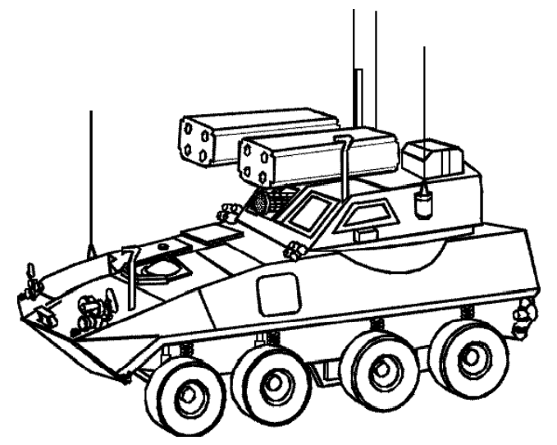

**Fig. 4** LAV-AD

Although the LAV-AD is not an organic weapon system to the Marine aircraft wing, it is important to be aware of its associated organization, configuration, and operating characteristics. Stinger gunners and other Marines with Stinger backgrounds could be assigned to the light armored reconnaissance battalion to employ the LAV-AD. Although the tactics, techniques, and procedures associated with LAV-AD operations are still under development, it is likely the LAV-AD will be used in much the same manner as an Avenger-equipped LAAD unit in direct support of a maneuver element.

The current concept of employment states that the primary mission of the LAV-AD is to provide local air defense for the light armored reconnaissance battalion, operating well forward of the fire support coordination line. It also outlines the planned table of organization that calls for an antiair warfare officer to command the LAV-AD company and Stinger staff noncommissioned officers and gunners to serve as crewmembers.