**6. Missile Overview Functioning**

The goal is to discover how to develop a tactical missile system either to counter an expected threat to one's own defended area (a defensive system) or to destroy or do significant damage to the enemy's defended area (an offensive system). This means designing the external configuration of the airframe so as to provide sufficient capability (speed, range, and manoeuvrability) to accomplish the mission planned for the system.

The first task is to ascertain the threat and, on the basis of feasible battle scenarios, develop a missile system concept to counter it. That concept will establish broad requirements in most technologies. The aerodynamicist must carry out his preliminary design study while recognizing the limitations on his options that are imposed by necessary choices in the other technologies or subsystems, as indicated

in Figure 1 and discussed in the next section. The mission analysis should lead to design goals for range, speed, and manoeuvrability of the missile, fuzing and warhead needs, and an overall guidance philosophy. At this stage, first-cut individual choices can be made by the several related technologies to achieve the mission. Modifications to those choices will be made as more-detailed interrelated studies of subsystem performance are made. Thus, a baseline configuration can be established from which further development can proceed.

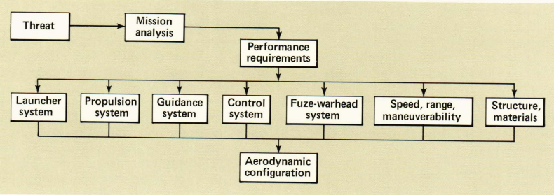

**Fig. 1** Factors and systems affecting the design of aerodynamic configurations

*Launching*

Besides restricting the missile's weight, length, and span, the launching system may restrict its permissible motion early in flight. Also, such factors as the motion of the launcher and winds or extraneous flow fields about it will affect the missile's design. The external shape might also be affected by launching shoes or other devices that guide the missile out of the launcher. Such appendages add drag and weight and can affect the missile's stability or controllability. The span limitation for a given launching system may require lifting and control surfaces to be folded, which adds to missile weight and drag and introduces a potential dynamic disturbance during deployment. The aerodynamic design must be done with full knowledge of these considerations so that detrimental effects can be minimized.

*Propulsion*

A missile's shape may depend strongly on its propulsion system. Designers of air breathing systems prefer to locate the air inlets in areas free of degrading aerodynamic interference such as shock waves, vortices, or wakes. At the same time, the inlet itself may degrade the aerodynamic performance. Thus, a compromise must be made between propulsion performance and aerodynamic performance, or, if possible, a design should be sought that takes advantage of favourable interactions that improve thrust, lift, stability, and controllability or that reduces drag. As fuel is consumed, the centre of gravity may shift, thereby changing the controllability of the missile. In general, the centre-of-gravity shift is more troublesome with solid-fuelled propulsion systems than with liquid-fuelled propulsion systems, which have more flexibility in the location of fuel tanks. Offsets of the thrust axis from the centre of gravity may also occur for certain propulsion systems (e.g., strap-on booster systems) or may result from design tolerances or from centre-of-gravity travel that moves the centre of gravity off the thrust axis. Such offsets can result in overturning moments that require additional control capability from the airframe.

*Guidance*

The choice of guidance system will affect the demands on missile manoeuvrability and response, which, in turn, may affect the choice of lifting and control surfaces. Furthermore, the design of domes to protect guidance sensors usually calls for compromises. For example, a hemispherical dome is usually considered the optimum choice for the sensors, but it has high drag. A dome with a high fineness ratio (i. e., length/ diameter ratio) has low drag, as shown in Figure 2, but tends to degrade the reception of signals by the seeker. A guidance system that uses interferometric homing with spike-like antennas at the nose of the missile can have significant effects on the stability and control as well as on the drag of the configuration. Air-data probes needed for setting autopilot gains or for regulating fuel flow may' have similar effects, depending on their placement.

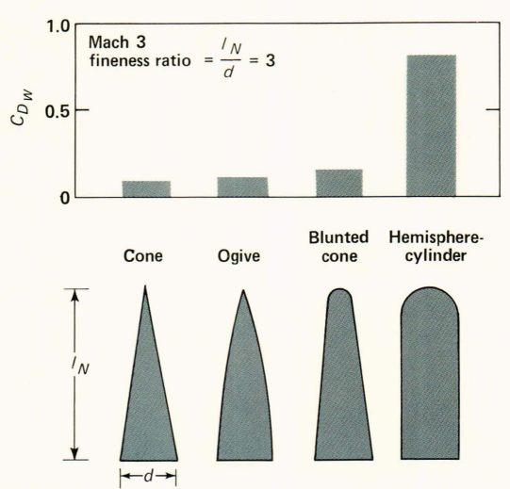

**Fig. 2** The effect of sensor dome bluntness on the wave drag coefficient *CDW*

*Warhead and Fuze*

The demands of the warhead and fuzing on the aerodynamic performance occur primarily during the brief interval prior to target engagement when the missile should be placed in a position and an attitude that will maximize the kill by the warhead. The other subsystems (guidance, control, propulsion) must work in concert with the airframe to provide this favorable condition. The aerodynamic design is also influenced by the location of the warhead (usually a very dense package) because it affects the missile's center-of-gravity location and travel.

*Autopilot and Control*

Three aerodynamic control systems use all-movable control surfaces: canard controls located well forward on the missile, tail controls located well aft, and wing controls located near the midbody. Although several early missiles used wing control (Talos, Terrier I, J and Sparrow), the missiles requiring high manoeuvrability generally resort to tail control. With canard control (Figure 3a) or tail control (Figure 3b), maneuverability is achieved by having the entire airframe at an angle of attack to the airstream and is controlled by forces from small surfaces at a large distance from the missile's center of gravity. A wing-controlled missile (Figure 3c), on the other hand, operates at a much smaller angle of attack and derives a large portion of its lift from the deflected wings. Canard controls can be placed near their source of information - the guidance package (which is usually far forward) - but their effectiveness may be partially compromised by "interference" moments from surfaces situated downstream from them. In some cases the control moment from forward controls (canard or wing) may be greatly diminished or even reversed through interference moments from the aft surfaces. An illustration of interference effects for the wing-controlled missile of Figure 3c is shown in Figure 4.

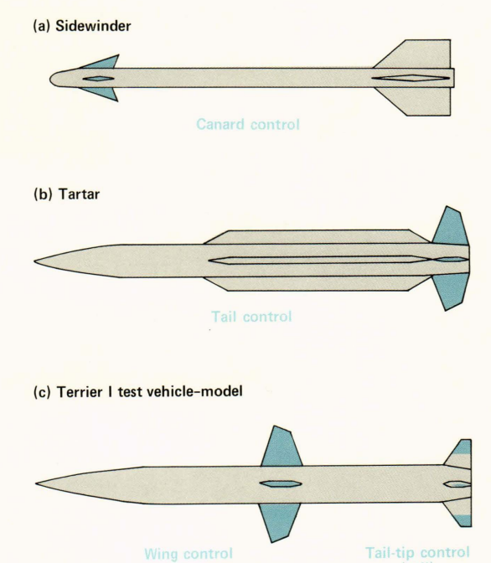

**Fig. 3** Type of aerodynamic control

The force normal to the missile centerline (proportional to the coefficient CN) increases nearly linearly with wing incidence when the body is lined up with the flow (α = 0), as shown in Figure 4a. When the tails are not present, the force is given by the colored curve. The down wash on the tails from the deflected wings produces a downward force, causing the resultant force on the configuration to drop to the black line. This downward force results in a nose-up pitching moment (proportional to the coefficient CM that overpowers the nose-down pitching moment from the wings (colored line in Figure 4b) to yield a resultant nose-up pitching moment for the full configuration (black line). The effect of down wash is the difference between the two curves in each case. Other types of aerodynamic controls are tip controls and trailing edge controls in which only a portion of an aerodynamic surface is rotated to produce control forces.

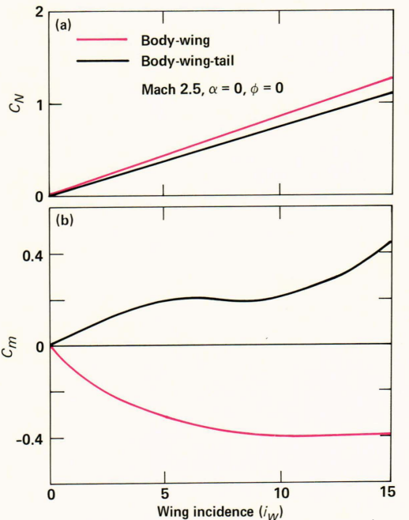

**Fig. 4** The effect of downwash from wing on tail as a function of wing incidence