**8. MISSILE GUIDANCE AND CONTROL SYSTEM**

***Learning objectives:***

*- explain the missile guidance loop;*

*- describe in general terms the active, semi active and passive systems;*

*- describe the logical process that is needed to determine the required flight path corrections based on the sensor measurements (guidance laws).*

***8.1. Introduction***

Guidance is a generic term that describes the hardware, the functions, and the processes used to steer a missile to intercept a target. Steering a missile to a target is analogous to steering any other vehicle, e.g., an automobile. The driver visually senses the continuously changing position of the automobile relative to a target, e.g., the garage doorway. This stream of visual information is passed to the driver’s brain where it is processed and used to generate control signals that are transmitted to his arms and hands for positioning the steering wheel. If the steering wheel is turned too much or too little, the changing scene reveals the error, and revised control signals are transmitted.

Continuing the analogy and for the moment restricting the discussion to a missile with a seeker, the eyes of the missile are the seeker head its brain is the combination of the seeker electronics processor and the autopilot, and its nerve system (muscle control) and muscles are contained in its control system. Any such process in which the error is continuously observed, i.e., measured, and corrections are made to reduce the observed error is a closed loop process. In this application the process is described by the guidance loop illustrated in Figure 1.

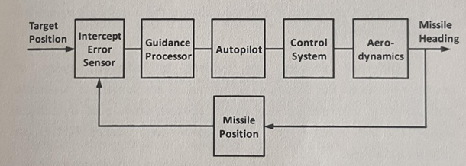

**Fig. 1** Guidance Loop

Referring to Figure 1, the sequence of events in guiding a missile begins when the seeker (intercept error sensor) senses the scene and determines the instantaneous intercept error. The guidance process, then determines the appropriate maneuver command, based on the guidance law to reduce the error. The autopilot in turn determines the control that is needed to achieve this command and transmits the control signals to the control system actuators to deflect the control surfaces. The control surfaces aerodynamically change the heading of the missile in a direction to reduce the heading error. The loop is closed as the intercept error sensor determines the new instantaneous intercept error.

The distinction among the various components of the guidance and control system is often blurred by the very close relationships and interactions among their functions. For example, in some missiles the autopilot function-to translate the steering error signal into a control command—is handled entirely by the steering signal amplifier and the valve that regulates the pressure on the fin actuators; is no separate box or component called “autopilot”.

As in all aspects of missile design, there are tradeoffs and compromises to be made in selecting a guidance system. Some of the factors to be considered are:

*1. Larger sensors are generally more accurate, but space and weight allowances onboard missiles are extremely limited.*

*2. Sensors operating at short range are more accurate. Therefore, a sensor on the missile becomes more accurate as the missile approaches the target, but a sensor on the ground becomes less accurate as the missile flies farther away from it.*

*3. Sensors are costly and those onboard the missile are expended with every launch.*

*4. Different sensors are subject to different types of countermeasures. For example, active radars are subject to detection and jamming, whereas passive optical seekers provide no detectable signal to the enemy but have their own susceptibilities to countermeasures.*

*5. Some types of sensors penetrate adverse atmospheric conditions better than others.*

*6. Certain RF sensors measure range accurately but measure angular position of the target much less accurately. Optical sensors measure angle accurately but do not measure range at all.*

As a result of tradeoffs among these and other considerations, several different guidance schemes have been used for surface-to-air missiles. Some of the basic concepts are described in the next section.

***8.2. Guidance Implementation***

In the analogy given earlier the eyes of a missile were represented by the seeker head, located at the front of the missile, and the guidance processing was done onboard the missile. There are other possible configurations, however. For example, a sensor could be located on the ground rather than on the missile, and the guidance processor also could be on the ground. In this case missile steering commands must be relayed horn the ground to the missile.

The various configurations for implementing surface-to-air guidance systems are broadly grouped into two categories: those in which guidance processing is located on the ground and those in which it is located on the missile. When guidance information is relayed from the ground to the missile, it is called command guidance. When the target tracker and guidance processing are onboard the missile, it is called homing guidance. Some guidance system configurations have sensors both on the missile and on the ground. These are more difficult to fit into an orderly grouping, but in general, when flight path correction commands are transmitted to the missile from the ground, some type of command guidance is implied. Guidance implementations using sensors and processors on the ground and implementations using onboard guidance and tracking are described in the subsections that follow.

8.2.1. Ground Guidance and Tracking

Long-range missiles may require very large target-tracking sensors, too large to be carried onboard the missiles. Also very sophisticated high speed computations involved in guidance processing and Countermeasures rejection have in the past required computation equipment that is too bulky and heavy to be carried onboard the missiles. For these reasons missile systems have been developed with Sensors and computers located on the ground. Another reason for ground-based sensors and computation, even for short-range missile, with relatively simple guidance processors, is simply to keep the expendable flight hardware as simple and low in cost as possible.

Three forms of guidance implementation - command, track-via-missile and command-to-line-of-sight - that use sensors and processors located on the ground are currently being used by US Army surface-to-air systems.

*Command guidance* receives its name from the fact that guidance commands are generated by a guidance processor that is not a part of the missile. For a surface-to-air system these commands usually are determined by a guidance processor located at the missile launch point and transmitted to the missile. The measurement system consists of a target-track and missile-track radar located at the launch point as shown in Figure 2. Measured position data for the target and missile are fed into a computer also located on the ground. The computer calculates the guidance commands, and they are transmitted to the missile where they are carried out by the autopilot and control system of the missile.

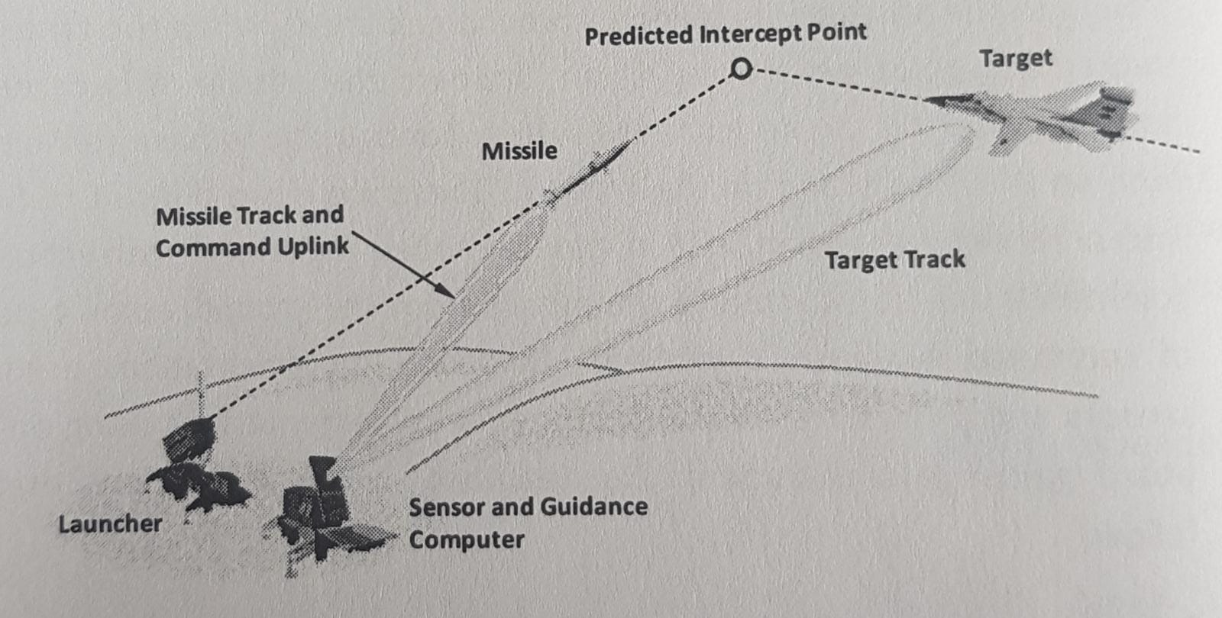

**Fig. 2** Command Guidance

One problem associated with command guidance is that measurements made when the missile is In the critical terminal phase of flight are the least accurate. At typical engagement ranges of surface-to-air command-guided missiles, these measurements contain such large errors that large miss distances result. One method used to overcome this difficulty is to use a very large warhead that is effective even when it is detonated at a large miss distance from the target. This of course requires that the missile be very large in order to transport the heavy warhead to the target.

Examples of command guided vehicles are the early Soviet surface-to-air missiles and the US Army Nike Ajax, Nike Hercules, Sprint, and Spartan missiles. The US Army PAC 2 uses command guidance with track-via-missile (TVM) and semi-active homing. Command guidance, however, is useful for the midcourse phase of long-range missiles, prior to the initiation of terminal guidance. In the midcourse phase the range from the missile to the target exceeds the capability of small onboard sensors, and the demand for accuracy-in the midcourse phase is less severe.

*Track via Missile:* more accurate guidance than command guidance is possible by placing a sensor on the missile so that as the missile approaches the target, the error produced by the inherent angular tracking inaccuracy is diminished by the shortened range from the missile to the target. In addition, the position of the target is directly measured relative to the missile. This eliminates the error that would have been produced by a ground sensor that estimates both the missile position and the target position and calculates the difference. If the measurements made by the onboard sensor are transmitted to a guidance processor on the ground, the system is called a track-via-missile (TVM) guidance system.

This system is illustrated in Figure 3. Since the onboard sensor must be relatively small, it may not be able to track the target at long range during the early and midportions of the flight. In this case, a large ground-based sensor is used to measure target and missile positions during the early and midportions of the flight when great accuracy is not required. This is called midcourse command guidance. When the range from the missile to the target becomes short enough, the onboard sensor locks onto the target, and the terminal guidance phase using TVM begins.

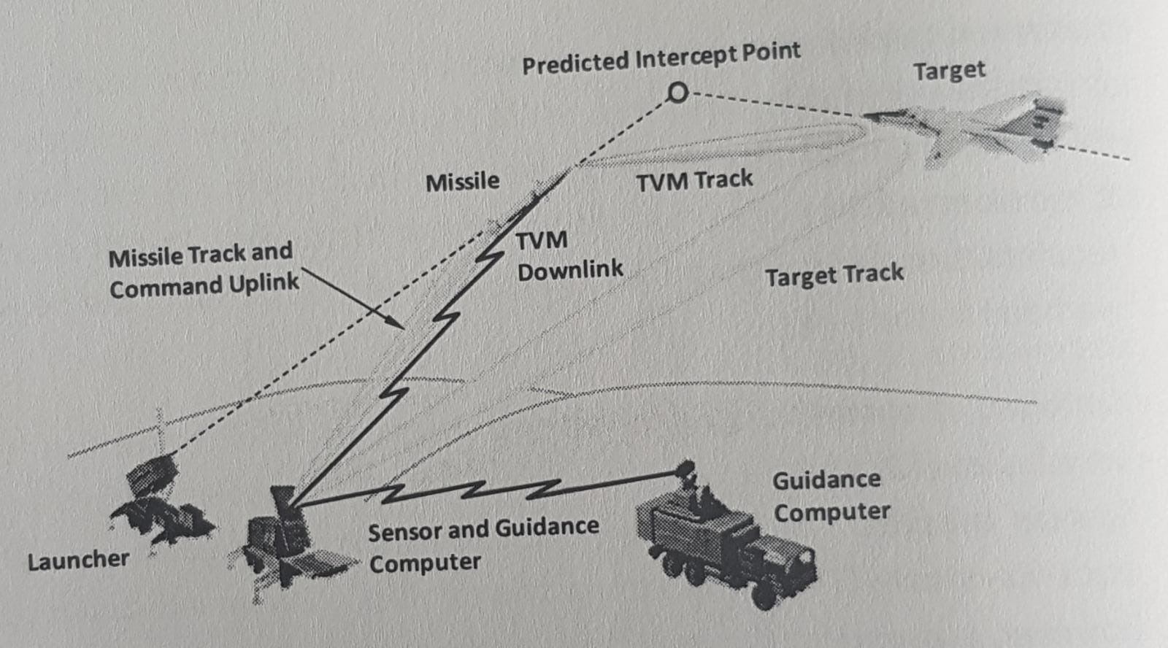

**Fig. 3** Track-via-Missile Guidance

*Command to Line-of-sight:* one way to implement guidance with a single ground-based sensor is to track the target and keep the missile within the target-track beam, Slight movement of the missile away from the center of the beam is sensed by the ground-based sensor, and correction commands are transmitted to the missile to bring it back to the center of the beam, This is called command-to-line-of-sight guidance. In a different implementation that cannot be classified as command guidance, the missile itself senses its position within the beam and develops its own guidance commands, this is called beam-rider guidance.

*Target Illuminators:* sometimes ground-based target trackers are used in conjunction with homing guidance. The purpose of the ground-based tracker is simply to illuminate the target with electro-magnetic energy. The onboard seeker tracks the target by using energy that originated at the illuminator and is reflected from the target. Thus the onboard system does not need to generate and transmit energy, so the cost, weight, and complexity of a missile are considerably reduced. Guidance implementations that use target illuminators are called semiactive systems.

*Onboard Guidance and Tracking:* to achieve truly small miss distances-permitting a minimal warhead and therefore a small missile requires that a target tracker (seeker) be onboard the missile. With the seeker onboard, sensor measurements become more accurate at the time accuracy is most needed, i.e., during final approach to the target.

Homing guidance usually implies that the guidance processing, as well as the seeker, Is onboard the missile-although TVM is a form of homing guidance—with the guidance processing performed on the ground.

Current applications of homing guidance usually measure only the angular rate of the line-of-sight from the missile to the target. This is the only measurement necessary to support a very powerful guidance law, i.e., proportional navigation implementation to measure the line-of-sight rate is relatively easy. In optical seekers part of the seeker head typically spins as a gyro. A torque is required to cause the seeker head to change its orientation in space to track the target. The voltage required to produce this torque is proportional to the angular rate of the line-of-sight to the target. In RF seekers the usual practice is to mount small gyros directly on the gimballed antenna platform to sense the angular rate of the antenna as it is driven to track the line-of-sight to the target. The outputs from these gyros are used as a measure of the line-of-sight angular rate.

8.2.2. Onboard seeker

Guidance employing onboard seekers can be implemented as active, semiactive, or passive systems. Each system is described in the subsections that follow.

An *active guidance* system generates radiant power on-board the missile and transmits it in the direction of the target. Power reflected from the target is received and tracked by the onboard system. An active system has the potential to measure relative bearing and range from the missile to the target angular rate of the line-of sight to the target, and the rate of range change (range rate) for use in determining guidance commands. Some of these measurements may not be used in a given missile design. A disadvantage of an active system is that the flight vehicle is burdened with the weight and space required by the power generation system. Also emissions of an active system may alert the target that a missile has been launched and give the target an opportunity to activate countermeasures.

In a *semiactive guidance* system the power used to illuminate the target is generated on the ground. The ground based system not only must acquire the target initially but also must continue to track the target throughout the engagement to provide power for the onboard seeker to track. This is a disadvantage since it ties up ground-based resources and prevents them from being applied to other targets and other missile launches. Another disadvantage is that, like the active system emissions from a semiactive system can alert the target that a missile has been launched.

A semiactive seeker has the potential to measure the bearing of the target relative to the missile and the angular rate of the line-of-sight from the missile to the target but it has no means of measuring range. If the guidance implementation has a rear-facing antenna on the missile to receive the direct illuminating signal as areference, it can measure the Doppler frequency, and range rate can be derived from the Doppler frequency. The use of range rate can be important-not so much to guide the missile but to discriminate the target from clutter and countermeasures.

A *passive guidance* system transmits no-power. The power tracked by the onboard seeker is either generated by the target itself (RF or IR), is reflected power generated by a natural source (solar), or is background power blocked by the target (UV). Once a passive seeker is locked onto the target and launched, there is no more need for support from the ground-based launch system. This gives rise to the concept of “fire and forget”, which permits the ground-based system to turn its attention to new targets and new launches. Passive seekers have the potential to measure relative bearing and the angular rate of the line-of-sight; they cannot, however, measure range or range rate.

***8.3. Guidance Laws***

A guided missile engagement is a highly dynamic process. The conditions that determine how close the missile comes to the target are continuously changing, sometimes at a very high rate. A guidance sensor measures one or more parameters of the path of the missile relative to the target. A logical process is needed to determine the required flight path corrections based on the sensor measurements.

This logical process is called a guidance law. The objective of a guidance law is to cause the missile to come as close as possible to the target. Guidance laws usually can be expressed in mathematical terms and are implemented through a combination of electrical circuits and mechanical control functions.

The two basic criteria on which guidance laws are based are that the guidance must (1) be effective under anticipated conditions of use and (2) be able to be implemented using the particular sensor configuration selected. A number of different schemes and their many variations have been used for missile guidance, chief among which are intercept point prediction, pursuit, beam-rider, proportional navigation, and methods based on modem control theory.

8.3.1. Intercept Point Prediction

Ideally, a missile could be guided simply by projecting the target position ahead by an amount corresponding to the time of flight of the missile and steering the missile to that point. In reality this is not an easy task. First, the target is not likely to cooperate by flying a predictable path. Second, the missile time of flight cannot be predicted accurately. Even the future velocity history of the missile is uncertain it is affected by unpredictable variations in motor thrust, atmospheric drag (which is caused partly by the very control commands that are to be determined), and the wind. Since predictions cannot be made accurately, the engagement conditions must be assessed continuously and the guidance commands updated based on current information. The accuracy of guidance using intercept point prediction depends largely on the accuracy of sensor measurements.

Intercept point prediction is applicable only when missile and target positions and velocities are both available. Command guidance systems meet these requirements.

8.3.2. Pursuit

One of the most obvious and primitive guidance laws is pursuit guidance, in which the missile velocity vector is directed toward the position of the target at any instant in time (8). Pursuit guidance has been labeled “hound and hare” guidance because, presumably, it is the guidance law used by a dog chasing a rabbit. Anyone who has observed such an engagement however, can testify that even a dog knows that leading the target i.e., anticipating its future position, improves the chances of intercept. A variation of pursuit guidance that introduces the concept of leading the target is deviated pursuit guidance. In this form of guidance, the angle between the missile velocity vector and the line-of-sight to the target Is held constant. Both, the pursuit and deviated pursuit guidance laws require a very high missile turning rate close to the time of intercept. Since there are physical limits on the turning rate that can be achieved by a missile, the result is the missile misses the target. The magnitude of the miss can be small for slow targets or for near-tail-chase engagements, but in general, pursuit guidance is not effective in the surface-to-air role and is not used.

8.3.3. Beam Rider

If a surface-to-air missile system is being used to defend a relatively small area the intercept ranges can be short enough that the accuracy from a ground-based sensor is acceptable, thus the cost and complexity of an onboard target sensor are eliminated. The missile system can be simplified further by eliminating the ground-based missile tracker; however, such elimination leaves only one way to keep track of the missile and that is to keep it within the target-track sensor beam. As the missile begins to move away from the beam, this movement is sensed either by the ground sensor or by antennas on the missile, and control commands are provided to hold the missile in the beam. This is called beam-rider guidance and is illustrated in Figure 4.

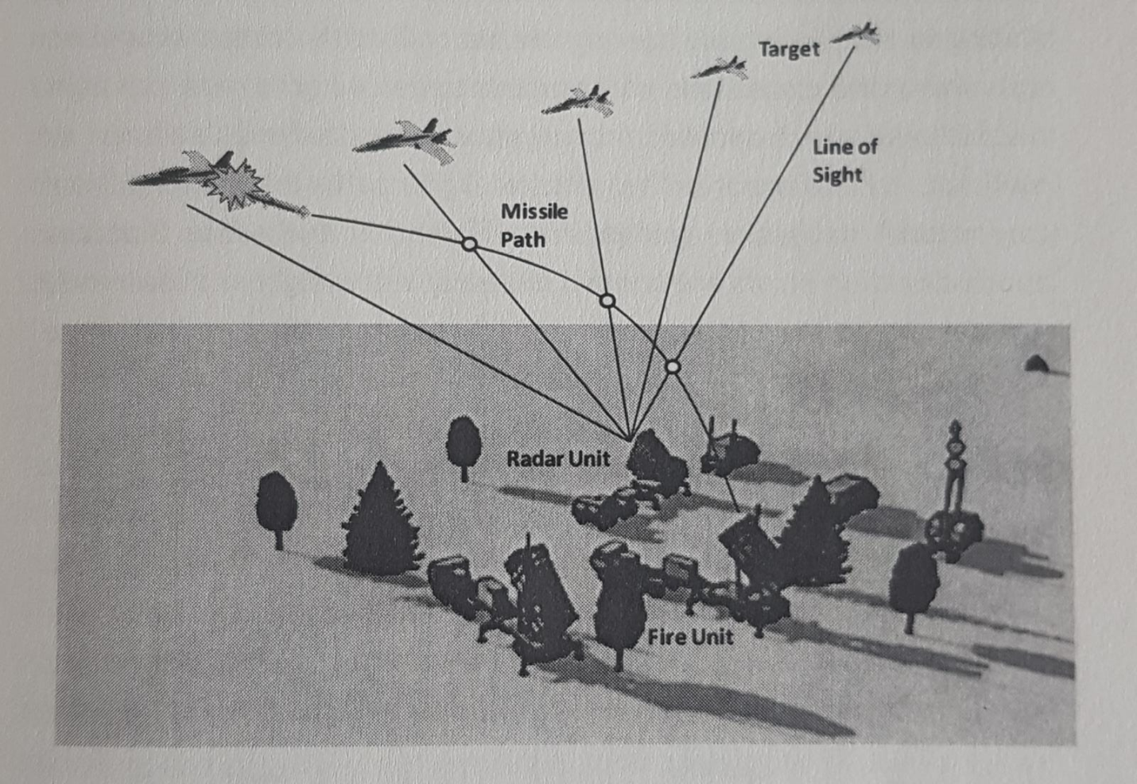

**Fig. 4** Beam-Rider Guidance

As the target moves, the target-track beam follows it, and the missile flies up the beam. With no tracking error and perfect missile maneuver response to the control commands, the missile would eventually intercept the target. In reality, however, the miss distance depends on how well these functions are performed.

A disadvantage of beam-rider guidance is that, although some target lead is inherent in the system, not enough lead is provided early in the flight, which results in an inefficient flight path. In some crossing geometries, the case in which a missile crosses the target, this places a severe maneuver requirement on the missile near its terminal phase, which may exceed the maneuvering capability of the missile.

A number of surface-to-air missiles developed by the Soviets and a few developed in Western Europe used some form of beam-rider guidance. The US Army does not currently have surface-to-air missiles using beam-rider guidance, which is essentially an obsolete technique.

8.3.4. Proportional Navigation

The guidance scheme that has proven to be extremely effective is proportional navigation. In proportional navigation the missile is steered so as to cause the angular rate of the missile flight path to be proportional to the angular rate of the line-of-sight from the missile to the target. The proportionality factor, called the navigation ratio, is usually set between 3 and S, i.e., the turn rate of the missile is three to five times the angular rate of the line of-sight. The result is that the angular line-of-sight rate is driven toward zero, and the missile is steered to a flight path in which the bearing angle to the target tends to remain constant as shown In Figure 5. One basic tenet of Ship piloting is that “constant bearing means collision”. It can be shown that under the conditions of constant target velocity and constant missile velocity, proportional navigation does indeed lead to an Intercept. Furthermore, the missile flight path that results from proportional navigation guidance Is efficient in the sense that any launch-direction errors are steered out early in the flight and leave only minimal corrective maneuvers to be required near the terminal phase in which flight path corrections are critical. For the stated conditions (constant velocities) proportional navigation has the same effect as predicting an intercept point and steering the missile to that point, but without the need to measure range or positions.

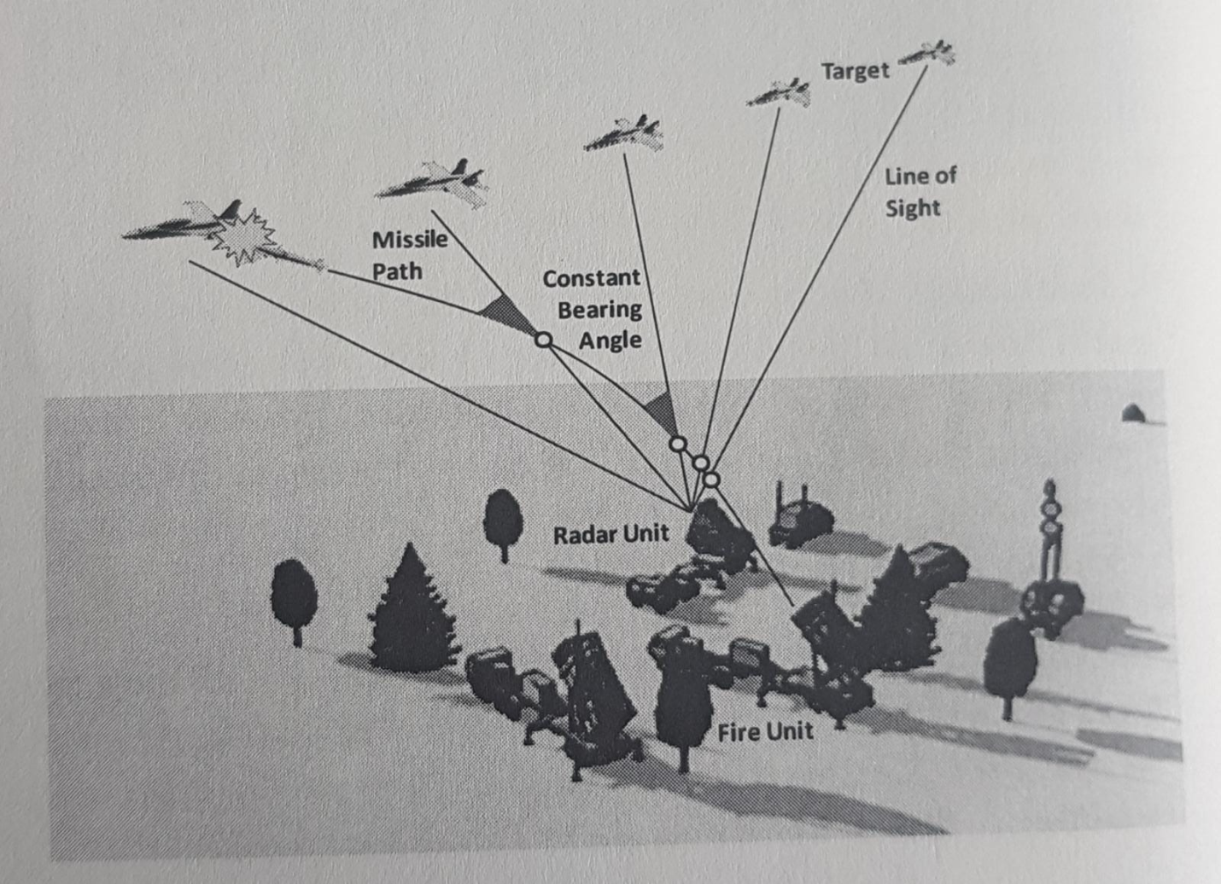

**Fig. 5** Proportional Navigation Guidance

In actual engagements neither the target velocity nor the missile velocity is constant; therefore, the basic premise on which proportional navigation is based is not valid. Proportional navigation is so robust, however, that acceptable miss distances can be achieved even against targets that perform relatively severe evasive maneuvers if the missile response time is short enough and if the missile is capable of sufficient acceleration in a lateral maneuver, Any target or missile accelerations in the early or midportions of the flight are sensed by the seeker as a change in line-of-sight direction. This leads to steering commands that soon null the perturbations produced by the accelerations. If the accelerations are continuous, such as during missile boost or when the target is performing a continuous turn, the steering commands cause the missile flight path to change continuously to keep up with the changing situation with only a small lag. The magnitude of this lag, combined with the limits on the ability of a missile to maneuver, determine the magnitude of the miss distance.

For proportional navigation to be used in its strictest sense, a measure of missile speed is required because the acceleration of the maneuver necessary to produce the desired flight path turn rate depends on missile speed. Since the effectiveness of proportional navigation is relatively insensitive to the navigation ratio, approximations can be made without seriously affecting its usefulness as a guidance premise. For example, a small error in the estimation of the acceleration of the maneuver is equivalent to a small change in the navigation ratio. Since missile speed is usually not available, closing velocity (if available) or some other approximation of missile velocity can be used to determine the acceleration of the required maneuver. In fact in practice an acceptable approximation to proportional navigation is simply to make the magnitude of the fin deflection proportional to the angular line-of-sight rate. The actual lateral acceleration achieved-and thus the navigation ratio achieved--depends on the missile configuration, Mach number, and air density. The ratio of achieved acceleration to angular line-of-sight rate is called the system gain.

In the early part of the missile boost phase, the missile speed is relatively low. Proportional navigation guidance does not anticipate that the speed will soon be much greater but provides guidance commands based only on the current seeker angular rate. This puts the missile on a course with a large lead angle consistent with the current speed. The lead angle, however, is much too large as the missile speed increases and requires a flight path correction back to a Smaller lead angle. To prevent this unnecessary maneuvering, the navigation ratio is sometimes intentionally shaped, i.e., its magnitude is changed with time. A low value of navigation ratio early in the flight Slows down the missile response to early misleading guidance commands, whereas a high ratio as the missile approaches the target permits fast response to target evasive maneuvers.

Proportional navigation is particularly applicable to passive homing guidance implementations because the line-of-sight angular rate is the only necessary input. Some form of proportional navigation (sometimes with the addition of biases) is employed in essentially a) Army missiles that have seekers. Because of its simplicity and effectiveness, proportional navigation is also sometimes used inmidcourse command guidance. Future missile guidance processors will take advantage of the greatly increased onboard computational power to integrate modem control and optimization techniques.

8.3.5. Optimal Guidance

Aircraft and pilot support systems are being developed with the capability to maneuver with very high lateral accelerations. With the development of these highly maneuverable targets, the usefulness of classical guidance laws, such as proportional navigation, is becoming marginal. In addition, countermeasures techniques are becoming increasingly sophisticated in their ability to introduce noise and deceptive data into the missile guidance processor. Consequently, there is a need to improve surface-to-air missile capability to meet these threats. Missiles are being designed presently with improved capabilities that include guidance laws that can deal more effectively with target evasive maneuvers and noisy, deceptive guidance data. These guidance law improvements have been made possible by several recent technological advancements.

Modern estimation and control theory provides the framework for the development of guidance laws that are closer to optimum. These modem advancements in control theory were developed in the late 1950's and early 1960s. Modem estimation and control theory is based on a time-domain approach that uses state variables to describe the condition of the system being controlled and incorporates optimal estimators such as the *Kalman* filter. In theory these methods allow “optimal" separation of the target signal from the noise by using a priori information about the missile and target dynamics and noise *covariances*. Missile and target states other than line-of-sight rate can be estimated even when not measured, provided they are mathematically observable.

During the late 1960s and early 1970s, a few missile designers examined the possibility of applying these advanced techniques in missile guidance. They concluded that except in the most simplistic and unrealistic cases, the mechanization of such algorithms in real time onboard a small missile was not feasible because the calculations involved procedures that could not be accomplished efficiently with the techniques that were then available.

Several things have changed since that time to make implementation of guidance laws based on modem optimal control techniques possible. New theories have appeared, and old ones have been extended and refined. Several new numerical techniques for solving complex equations have been developed. Finally, and most important, the microcomputer has been developed. These advances now make implementation of improved guidance laws practical, and future generations of missiles are expected to be able to address the problem of noisy data, with some data being of higher quality than others, and the problem of uncertainty in factors such as future target maneuvers.