**6. Romanian Anti-Aircraft Artillery System.**

**2x35 mm Oerlikon Gun GDF-003**

***Learning objectives:***

*- explain the architecture of the 35 mm battery;*

*- identify and describe the main parts of GDF 003 AA and 35 mm Gepard;*

*- develop a comparative analysis of the performances of the two artillery systems.*

***6.1. Generalities***

It is a 2-barrel anti-aircraft cannon, 35 mm cal., produce by Oerlikon-Contraves, which can fight against air targets at low heights, as well as ground targets such as light armoured vehicles.

The gun can operate in 3 ways:

- normal mode - automatic cannon controlled by GSN/FCU;

- auxiliary mode – autonomous cannon controlled by the operator using a joystick and vision system;

- emergency mode – manual cannon controlled by the operator if absence of the main power supply.

The GDF-003 assembly is loaded on 2 auto trailers, the gun and the PSU (Power supply Unit) trailer with electric generators. Anti-aircraft gun 35 mm cal. “GDF 103 AA” is part of a battery level (Figure 1).

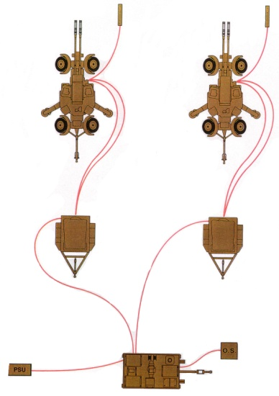

**Fig. 1 35** mm battery architecture

The 35 mm battery consists of the Fire Control Unit (GSN/FCU) and two anti-aircraft guns “GDF 103 AA”. The guns and GSN are connected by power generators (Figure 2, 3).

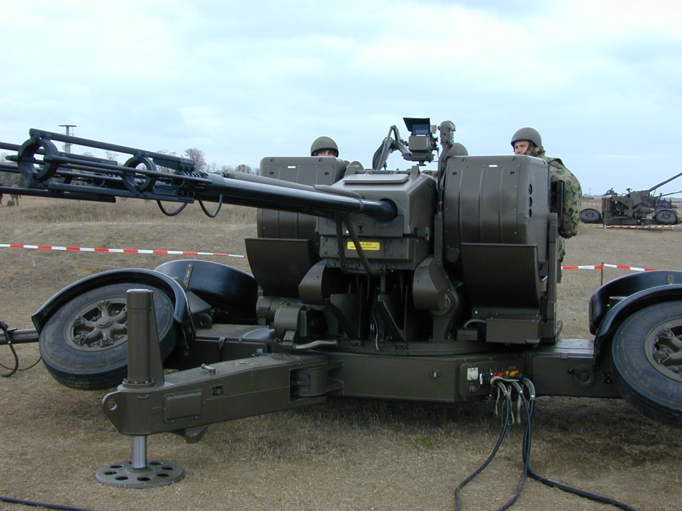

**Fig. 2** GDF-003

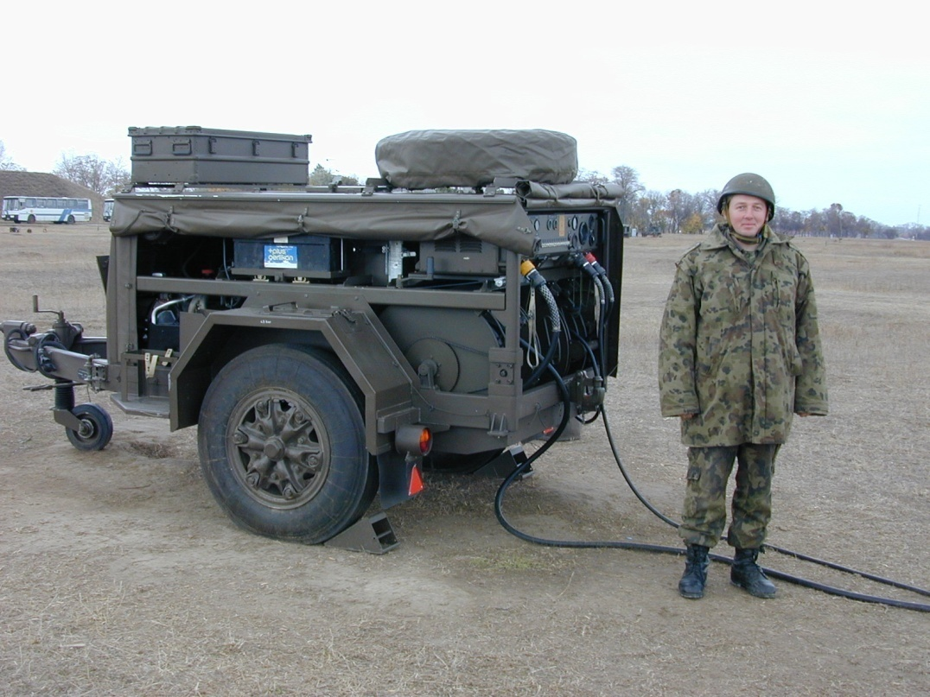

**Fig. 3** Power Supply Unit

The 35 mm anti-aircraft gun “GDF 103 AA” can be operated in two ways:

- Normal mode is automatic when GSN operators control the entire gun as part of the battery.

- If the gun is not connected to GSN, it can operate independently and successfully engage targets, in which case the Ferranti sight is used and normally the generator Group (GE/PSU) will provide the power required to operate the gun via the joystick (1). All sight devices can also be operated manually from the direction and height actuating levers (2) when there is no power source (Figure 4).

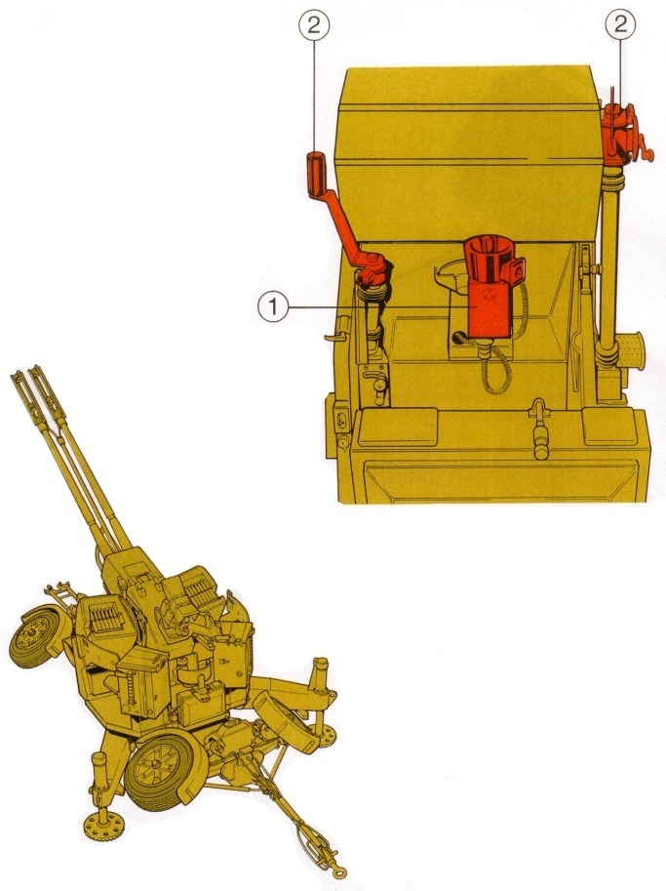

**Fig. 4** Tools for manual operation

***6.2. Main components***

*Weaponry:* There are 2x35 mm weapons on the carriage of each cannon. Weapons sub-assemblies include barrels, the locking mechanisms and the reloading mechanisms (Figure 5).

A lubrication system is mounted inside the cradle, in the weapons protection cover and on the upper carriage. It ensures that the moving parts of each weapon are greasing during shooting.

To slide on the cradle, each arm is fitted by means of runners and is controlled by the elastic connection: Pull brake (hydraulic) and collector with helical springs.

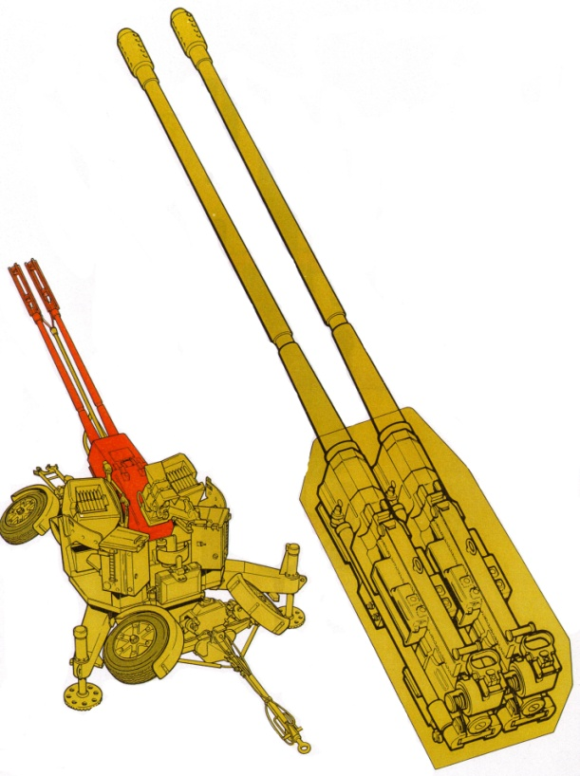

**Fig. 5** Weaponry

*Automatic loaders:* The weapons are powered by automatic loaders mounted on the cradle shoulders on the upper carriage. They move in height and direction with the gun (Figure 6).

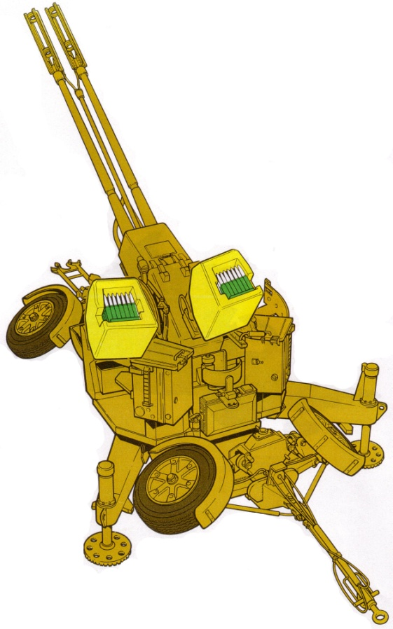

**Fig. 5** Automatic loaders

Each automatic loader is driven by a spring motor which, when necessary, is rearmed manually or electrically. In the mechanism box are transmission systems that align and unload each ammunition blade and automatically lead shots into the weapon.

The automatic chargers are supplied with full blades from the ammunition containers secured to the rear of the upper carriage.

*Upper carriage:* The upper part of the gun is the upper carriage. It consists of a platform which is connected to the lower side by a bearing. The platform can move via the bearing in the direction. Attached to the platform are two side walls containing the cradle shoulders (Figure 6).

The upper carriage moves in the direction by electric or manual operation.

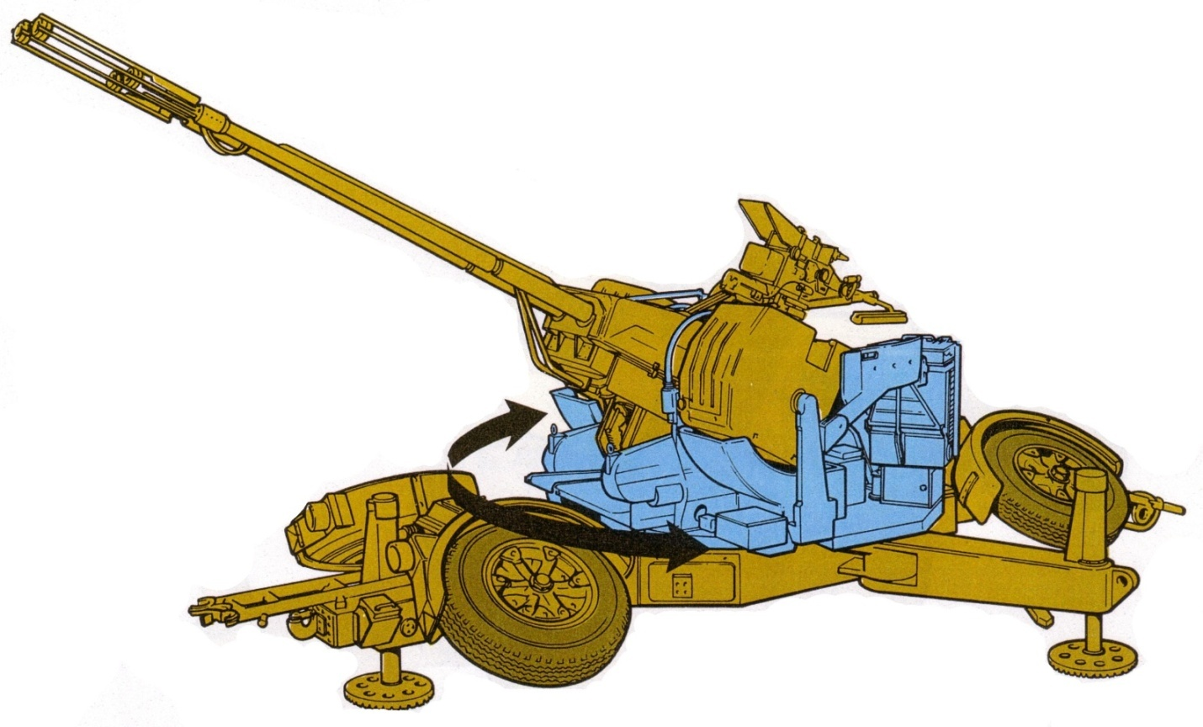

**Fig. 6** Upper carriage

*Sighting equipment:* When positioning the cannon, certain steering and height angles must be checked before the entire battery is ready for firing. The panoramic rear window (1) is mounted on the left shoulder. This is used for preliminary orientation and in addition for checks during firing.

They can be asked to aim and fire independently. For this purpose, the cannon is equipped with a Ferranti anti-aircraft sight (2). It is mounted by means of an articulated arm on the right-hand side of the platform and operated by the sight-operator. It virtually replaces some facilities that are typically provided by the UCF. Using the Ferranti cannon sight can engage air targets on any flight coordinate.

Attached to the Ferranti sight is a viewfinder for sighting and firing against ground targets (3). It is used only for ground targets (Figure 7).

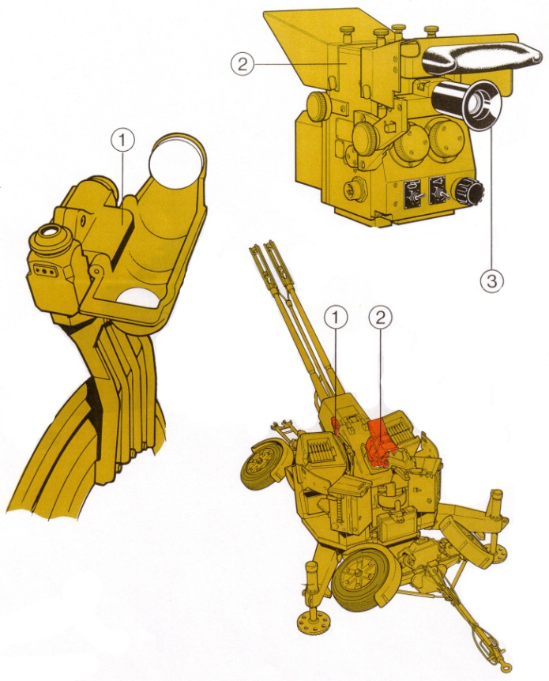

**Fig. 7** Sighting equipment

*Control panel:* The cannon commander controls the cannon during operation using the control panel. It is connected with a cable so the commander can stay out of the range of the cannon (Figure 8).

When the control panel is not in use, or if the sight operator is also the commander of the gun, for any reason, it is placed on the left side wall of the upper carriage.

The control panel is equipped with controls and verification lamps for operating the cannon.

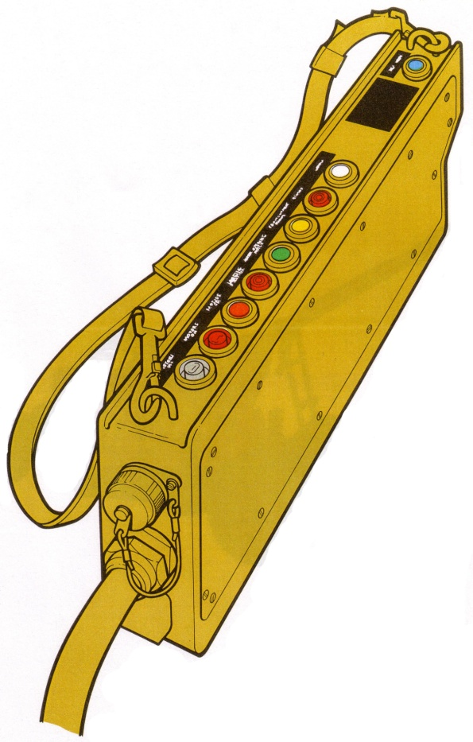

**Fig. 8** Control panel

*Lower carriage:*  The lower section of the tunnel is the lower carriage. It is equipped with 4 wheels with air brakes. Independent front and rear suspension axles give the cannon good road and field capabilities (Figure 9).

A drawbar is attached to the front when towing. The movement of the drawbar allows the gun to be moved manually into the pulling position. The rest deck for barrels during transport is fixed to the lower carriage.

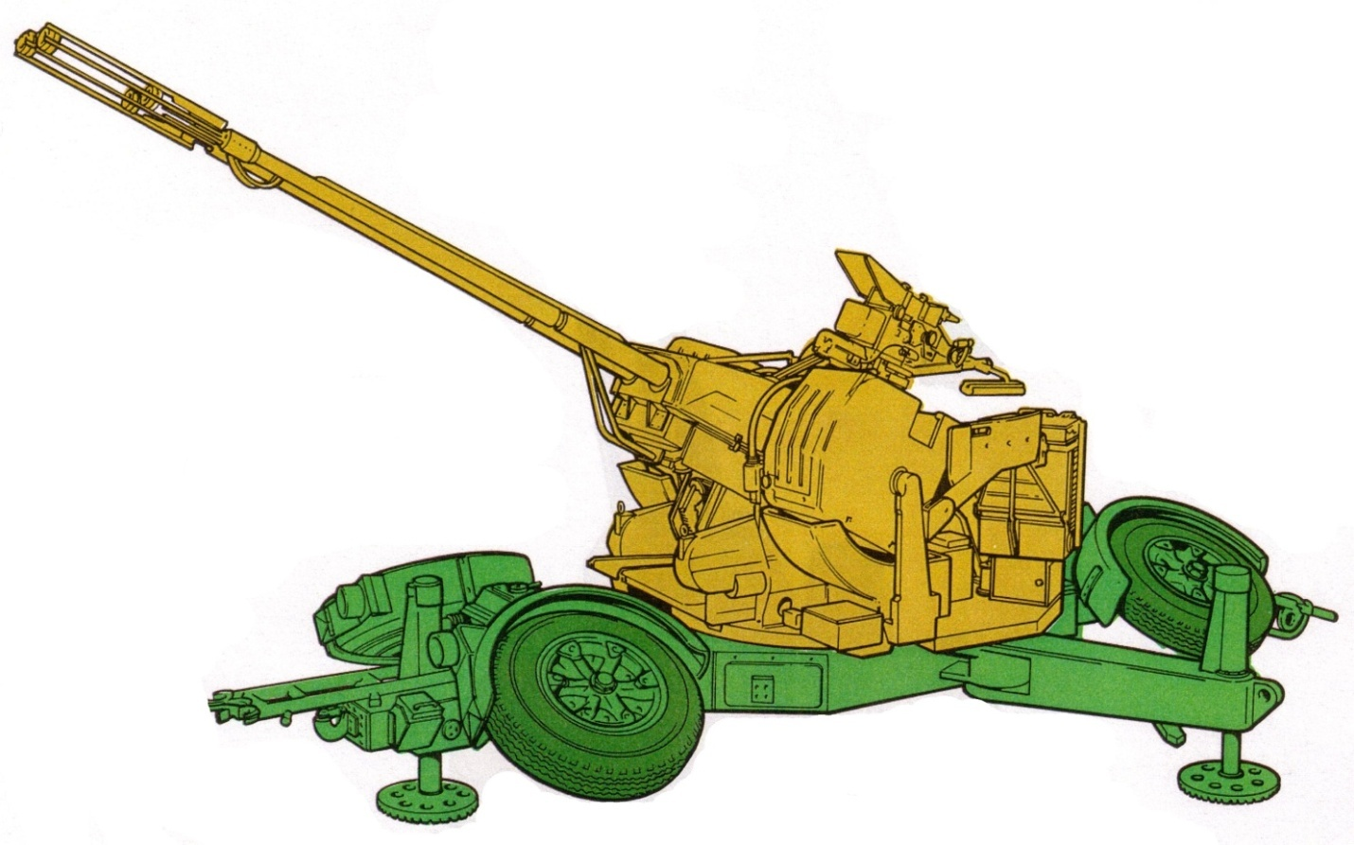

**Fig. 9** Lower carriage

The lower carriage frame contains, outside the air brake system, the hydraulic and electrical circuits with the control buttons and the corresponding connections.

Two folding jaws are attached to the center section of the lower carriage. In the firing position they are unfolded out. There are hydraulic jacks at the end of each arm and at the rear of the frame. They are used to place and set the gun in the firing position. The wheels are inclined so that the tunnel is as close to the ground as possible.

*Muzzle velocity measuring system and ammunition:* During the anti-aircraft firing, the speed measuring devices at the end of the barrels are attached to the muzzle (1). They measure the velocity of projectiles at the muzzle and allow the computer in the UCF to calculate the firing elements so that the meeting problem is resolved. Pulses from the muzzle velocity meters pass through the amplifying unit (2) on the platform before being transmitted to the UCF (Figure 10).

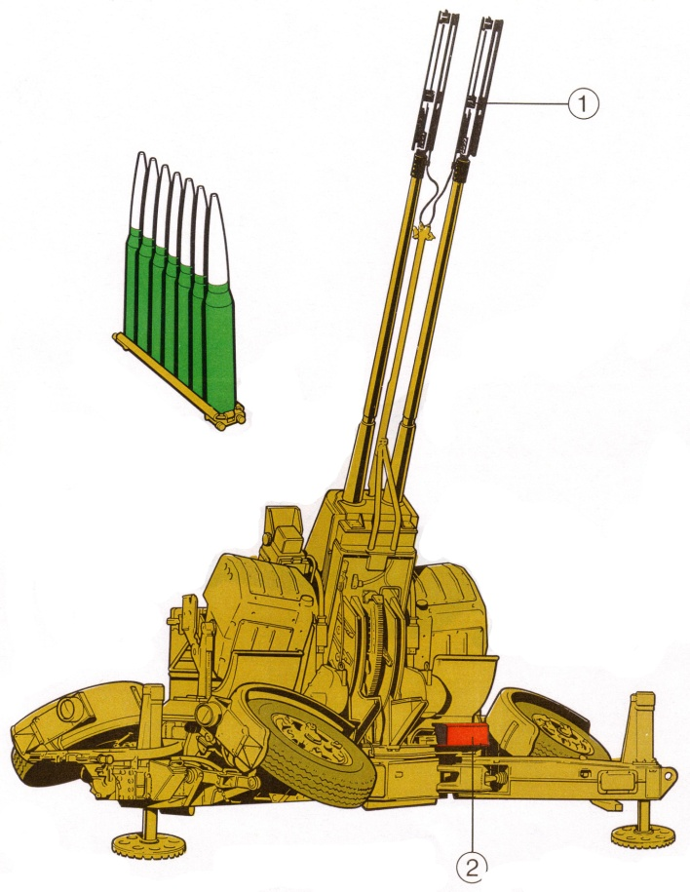

**Fig. 10** Muzzle velocity measuring system and ammunition

If the muzzle velocity measurement is not required, e.g. when the cannon is not connected to the UCF, the initial speed measuring devices shall not be used and the muzzle brakes shall be fitted in place.

Various types of projectiles are used for this cannon. The type of projectiles used depends on the targets on which the shot is defined (airfield or ground), or whether the mission is training, or fighting.

When fully loaded on the cannon, there are 238 shots, 56 in each automatic magazine (8x7 shot blades) and 63 in each ammunition container (9 7-shot blades).

***6.3. Overall dimensions and characteristics***

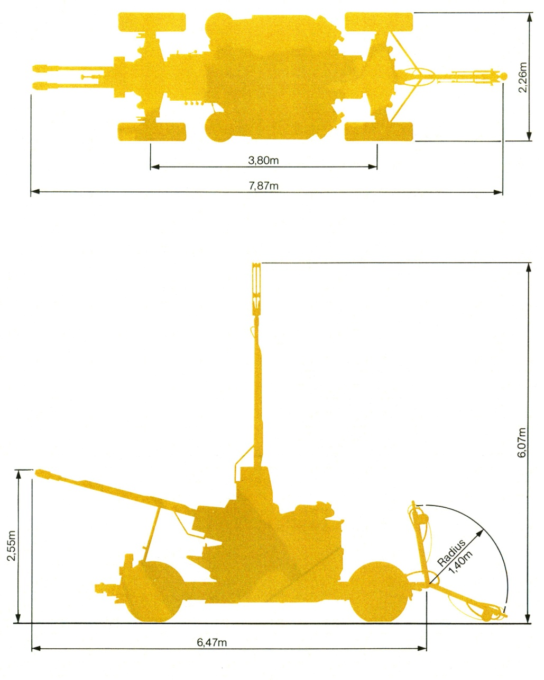

**Fig. 11** Overall dimensions

- Caliber: 35mm

- Rate of fire: 2*550 = 1100 rounds/min;

- Muzzle velocity: 1175 m/s;

- Type of ammunition:

* TP, TP-T,
* HEI, HEI-T,
* SAPHEI-T,
* BREAK UP.

- Mass: with ammunition and accessories ≈ 6800 kg; without ammunition and accessories ≈ 6400 kg.

***6.4. Power supply unit***

Each gun is supplied with electrical energy supplied by the power supply unit (PSU) mounted on a single-axle trailer equipped with an air brake system. (mass ≈ 2680 kg).

PSU consists of a VW internal combustion engine powered by normal gasoline that drives the generators and the amplifier. Generators supply electrical power for cannon. The amplifier provides power for the electrical movement of the gun (Figure 12).

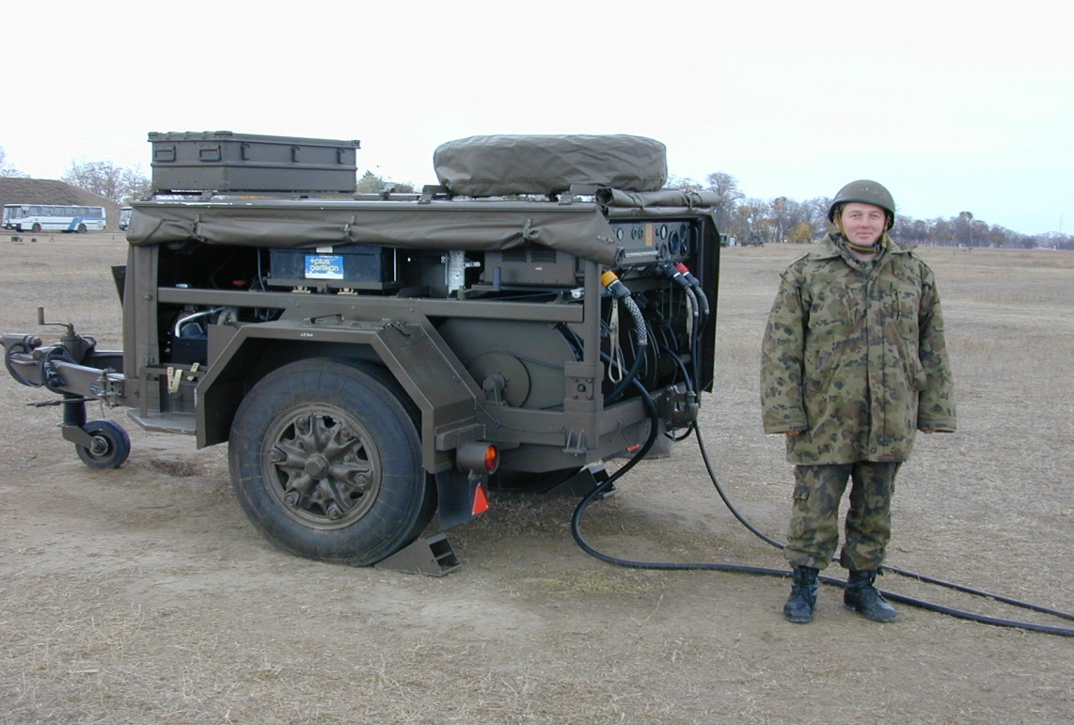

**Fig. 12** PSU

At the rear of PSU, the control unit contains the switches and control buttons. A 110 L capacity petrol tank inside PSU ensures good performance and the petrol canisters are placed on each side in front of the wheels. A spare wheel, which can be used for either cannon or PSU, is placed above PSU.

***6.5. Sector limiters of the GDF 103***

Sometimes it is necessary to restrict firing in certain sectors. Buildings or areas where other cannons are located, for example, may need protection. This is done using the sector limiter.

It is possible to select up to 3 distinct sectors or “safety windows” in the theoretical hemisphere surrounding the cannon (Figure 13). Where the coordinates of these areas on the cannon sector limiters are established, the electric firing lines of the firing system shall be interrupted whenever the gun is aimed in those directions. In any other direction, sector limiters do not interfere and firing can take place.

Sector limiters have no control of the mechanical operation of the fire trigger device, the mechanical fire trigger pedal.

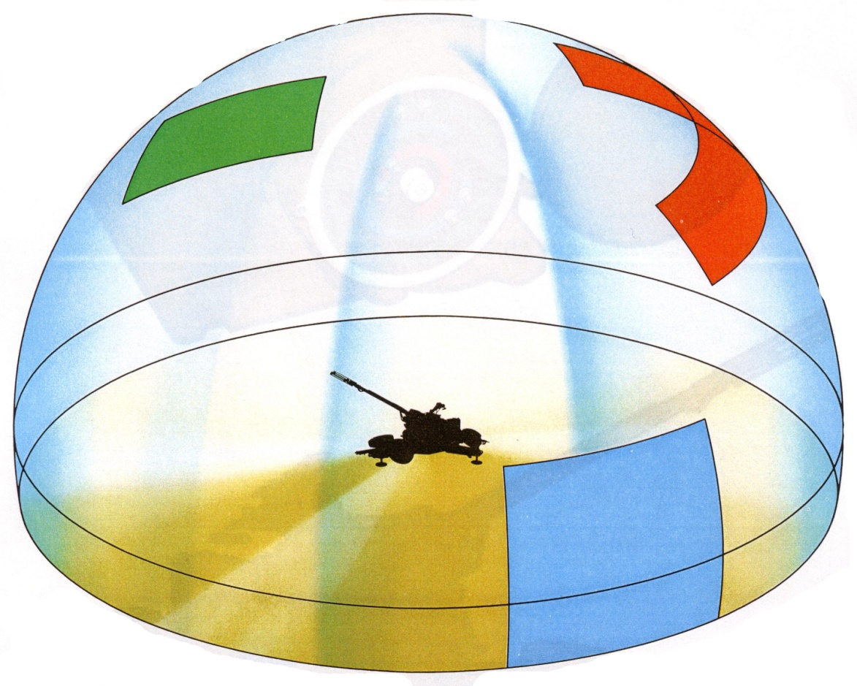

**Fig. 13** Sector limiters