**5. Radar and Tactical Commander Post.**

**SHORAR-TCP**

***Learning objectives:***

*- explain the basic functions of the Tactical Commander Post;*

*- identify and describe the main parts of TCP;*

*- describe the main responsibilities for TCP crew in relation to the use of Operations, Information, and Logistics Consoles.*

***5.1. Functions***

SHORAR-TCP performs the tactical control functions of the 35 mm AA system. It is connected with up to 4 GUN STAR fire units by radio or wired links.

SHORAR-TCP performs the following functions:

- discover the target;

- follow the target while scanning (TWS);

- classify and identify the target;

- assess the threat;

- distribute the target to a GSN/FCU;

- display the tactical scenario;

- display the air situation;

- control the 35 mm batteries.

***5.2. SHORAR-TCP architecture***

The SHORAR-TCP comprises the following main parts (Figure 1):

- radar system;

- tactical console;

- integrated IFF system;

- communications system;

- operations, information and logistics consoles;

- container.

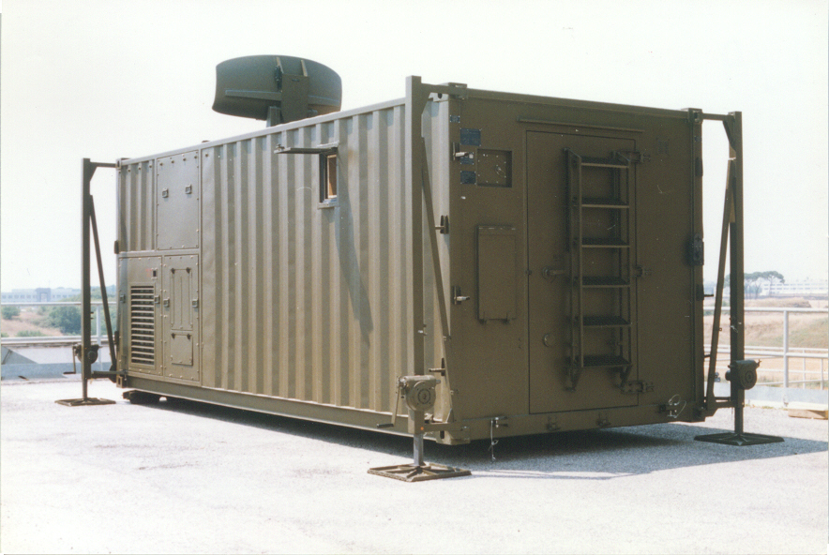

**Fig. 1** SHORAR-TCP

The running time is less than 5 minutes, for temperatures above 00°C and below 20 minutes, when the temperature is below 00°C.

*The radar system* is used for the detection and indication of low and very low altitude air targets, including airplanes and helicopters. Through its friend or foe identification (IFF) feature, radar can identify hostile or friendly targets and presents them on a circular observation indicator.

The radar system consists of three main subsystems:

* radar enclosure;
* radar processor;
* radar console.

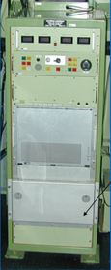All subsystems are inside the container (Figure 2, 3).

**Fig. 2** Radar processor

The radar system transmits an X-band RF radio frequency signal for target detection and a L-band RF for IFF target identification.

The X-band signal is generated by the pilot oscillator in the radar enclosure, which ensures the output to a unit transmission, a pulse train synchronized with the pulse repetition frequency. The pulse train is then amplified by the progressive wave tube, modulated and transmitted by the set of waveguides and the rotary to the broadcast antenna system.

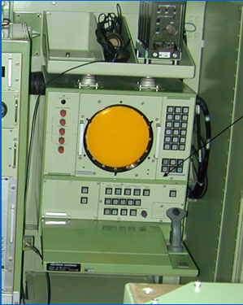

**Fig. 3** Radar console

The received signal (detected target) is detected by the antenna and sent by the rotary coupler to the pilot receiver / oscillator, where it is transformed into an intermediate frequency (IF) signal.

The oscillator and the IF intermediate frequency signal containing Doppler information about the moving targets are sent to the receiver for phase detection and video extraction of the received signal. The video signal is then sent to the electronic block (EC) where it is processed.

The control system processes the average noise signal used for automatic amplification control (AGC) and controls the functions that distinguish between helicopter flight and other aircraft.

Data Extractor Processor Processes and Controls Angular Data Chain and Executes Information Extraction for each target detected.

The processor-controlled video signal is then sent to the I/ O (input-output) processor of the radar console where it is processed and displayed as target information on the PPI circular observation indicator.

The radar console is the control center of the entire radar system. All system operation commands, both tactical and diagnostic (BITE), start at the radar console. The operation of the system is obtained through controls manuals and the interactive dialogue is done through the PPI circular observation indicator. Interactive dialogue allows the operator / computer interface to operate, test and diagnose.

The L-band signal is generated in the IFF friendly-enemy identification unit in the radar enclosure, which encodes and transmits a pulse frequency modulated RF radio signal to the IFF radiators of the antenna.

The received signal (aircraft identification) is decoded and processed, and the IFF video signal is sent to radar processor (RP). The IFF video signal is controlled by the PCB of the clock generator and sent to the console radar, to the I/ O (input - output) processor, where it is processed and displayed by the PPI circular observation indicator.

IFF information is also sent from the IFF unit to the RP radar processor, and then to the radar console for display on the PPI circular observation indicator.

*Radar Operating Modes* are:

* SR (Short Range) mode - used to detect the target in the range of 1.2-17 km, with a scan speed of 57 rpm;
* MR (Maximum Range) mode - used to detect the target in the range of 1.2-28 km, with a scan speed of 38 rpm;
* HCR (High Clutter Rejection) module - works in difficult environmental conditions and detects in the range of 1,2-17 km with a speed of 38 rpm.

SHORAR TCP is also equipped with an ECCM (Electronic Counter-Counter Measures) device for counteracting jamming. The system is able to track up to 20 targets using the "scan while scanning" algorithm (TWS = Track-While-Scan).The radar is interfaced to IFF equipment. The system can automatically distinguish in-flight helicopters compared to airplanes, up to a distance of 10 km.

*Communications system* consists of 2 PANTHER 2000 V radio stations for data communications, PANTHER V EDR for communications voice and an INTERCOM system for communications between the tactical commander, the radar operator, the console operator information, the operator of the operation console and the commanders of the firing units (Figure 4).

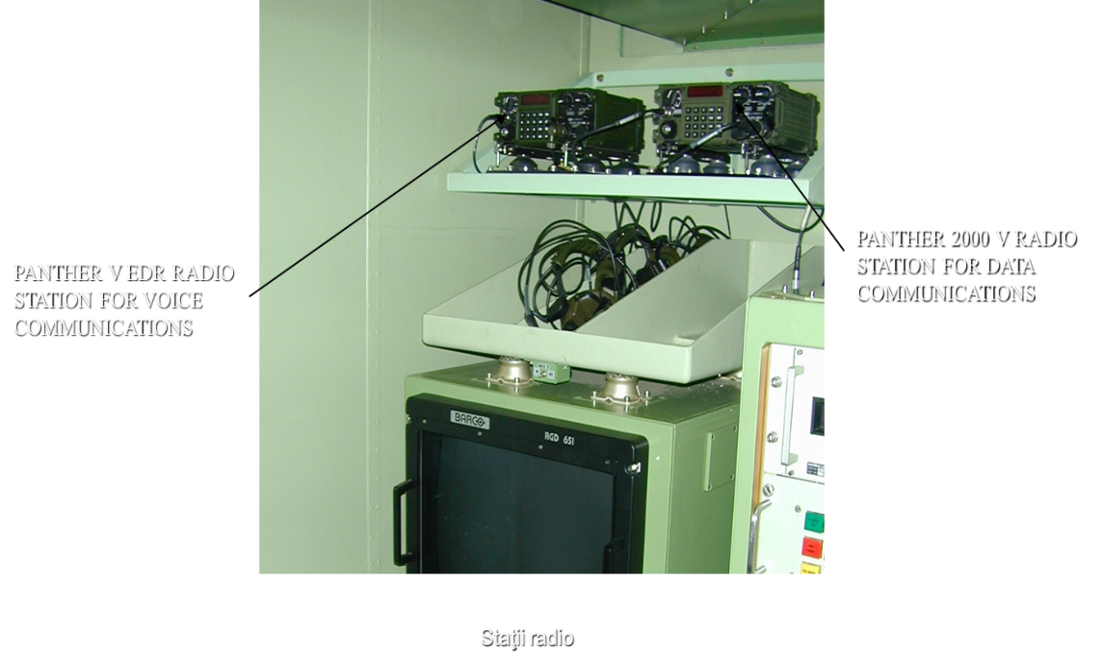

**Fig. 4** Communication voice and data stations

The INTERCOM system allows communication in the following modes:

* conference mode;
* selection mode.

The communication protocol between SR/ TCP and GSN/ FCU provides a main mode of radio communication, both for voice as well as for data, and a secondary mode of communication via wire, both for voice and data. A combined solution it is also possible if the layout distances from SR/ TCP are different for the four GSN/ FCUs.

The communication links between the GSN/ FCU and each cannon are made by wire (Figure 5).

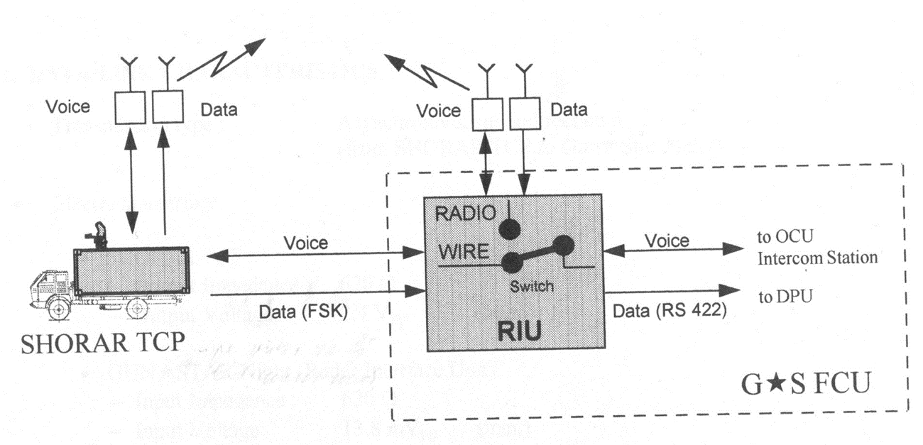

**Fig. 5** Communication links between SHORAR-TCP and GSN/FCU

***5.3. SHORAR-TCP crew***

The crew consists of 7 people: tactical commander, radar operator, information console operator, operations console operator, logistics console operator, primary assistant and secondary assistant.

*Tactical Commander*: is the commander of the battalion and four 35 mm firing units (batteries). During operations, he evaluates the tactical scenario through the tactical console from SHORAR-TCP. He communicates orders/ tactics to FCU commanders.

*Radar operator:* performs SHORAR-TCP Search Radar control; communicates with the Tactical Commander; selects Mode Radar operation commanded by the Tactical Commander; communicates with the Tactical Commander the Operational and functional situation Radar; turns all SHORAR-TCP subsystems on/ off.

*Information Console Operator*: coordinates information on early warning targets, data transfer from GPS to Tactical Console, and recording data and voice communications.

*Operations Console Operator*: optimizes mission development, site preparations, coverage Radar, firing range etc.; transfers location information to the Console Operator Tactical; updates, if necessary, the location according to the change of the tactical situation.

*Logistics Console Operator*: optimizes resources and refueling, maintenance activities, ammunition supply, personnel, spare parts availability, location, condition of equipment etc.

*Main Assistant*: helps with placement the SHORAR-TCP container and the commissioning of the SHORAR-TCP.

*Secondary Assistant*: assists at the placement, mounting, commissioning of SHORAR-TCP.

***5.4. Tactical Modes and Alignments***

SHORAR-TCP/ Gun Star-Night FCU / 30-35mm Air Defense Battalion has two possible tactical modes operation:

* Centralized (commitment decided by TCP);
* Decentralized (commitment decided by FU).

*In centralized mode*, threat assessment and trace designation at the firing unit is performed at the SHORAR-TCP level. If the battalion operates in the centralized mode, SHORAR-TCP performs Computer Aided Threat Assessment while designation of the most threatening target at the most appropriate firing units is performed by the Tactical Operator.

The connection between SHORAR-TCP and FU is made by campaign cables and/ or radio links and the maximum number of firing units operating in centralized mode is four. Centralized mode is recommended for better system performance and in addition for optimizing employment opportunities.

*In decentralized mode*, threat assessment and post-employment control are performed at the firing unit level by Gun Star-Night FCU or any other FU capable of receiving target data transmitted through broadcasting. If the transmission of the target traces is done through the radio channel and is not limited by the addresses for firing units, the maximum number of traces transmitted is ten. In the course of the battalion it is always possible to assign up to four Firing Units in centralized mode and other firing units in decentralized mode.

The following types of alignment between SHORAR-TCP and Gun Star-Night/ FCU are provided:

* direct alignment, when the exact orientation by geographical north of the elements of the division is not strictly necessary;
* alignment according to the exact orientation of the geographic North of all elements of the battalion.

The tactical mode of the battalion depends on the alignment system adopted.

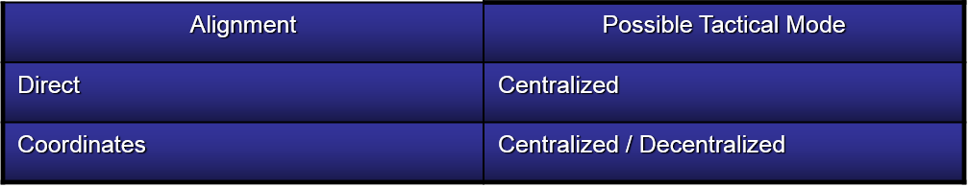

***5.4. Operations, Information, and Logistics Consoles***

*Operations console p*erforms the following operational functions (Figure 6):

- representation of the digital map of the battle district for the preparation of the division's missions;

- receiving and representing data about targets evolving outside the maximum SHORAR detection distance in the “red” alarm zone (respectively 50 Km);

- establishing the fighting device of the division and optimizing it by taking into account the tactical norms specific to the 35mm battalion;

- determination of radar coverage areas (division level), thermal sensors (shooting unit level) taking into account the information provided by the digital map and distance measurement;

- assessment of the air threat in the area of ​​combat actions;

- recording the information necessary for the reconstitution of combat missions.

*Information console* performs the following operational functions (Figure 6):

- representation of the digital map of Romania at a scale of 1: 500000 for the preparation of the future missions of the battalion;

- receiving and representing data about targets evolving outside the maximum SHORAR-TCP detection distance generated by ASOC or an independent detection radar;

- determination of radar coverage areas (division level), thermal sensors (shooting unit level) taking into account the information provided by the digital map and distance measurement;

- assessment of the air threat in the area of ​​combat actions;

- establishing and displaying alarm and pre-alarm zones;

- land analysis by displaying roads and access roads in an area of ​​60 km around the disposal position;

- measuring the distances to be covered by the division;

- the calculation of the fuel resources necessary for the movement of the division in order to occupy the combat device;

- audio recording and archiving of audio and data recordings of the mission;

- system status information.

*Logistics console* allows battalion resource management (Figure7):

- armaments, vehicles, fuels and lubricants, ammunition, spare parts stocks and accessories;

- personnel records.

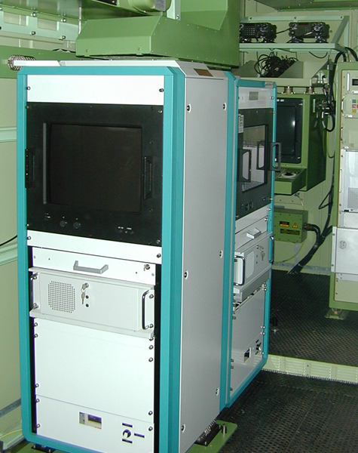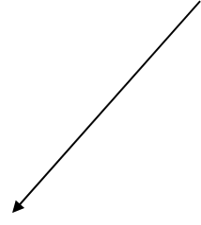





**Fig. 6** Operation and Information consoles

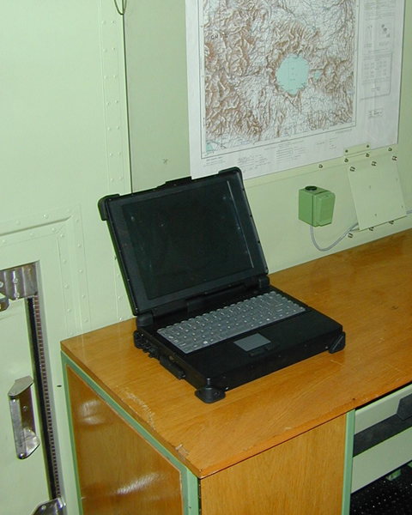

**Fig. 7** Logistics console

*The container* containing the SR-TCP system consists of a compact structure with a controlled internal environment and habitable and an open part, arranged to support all the closed elements in their own housings (Figure 8).



**Fig. 8** Equipped Container-interior design

ANNEX 1

**Technical Data of the Main Equipment**

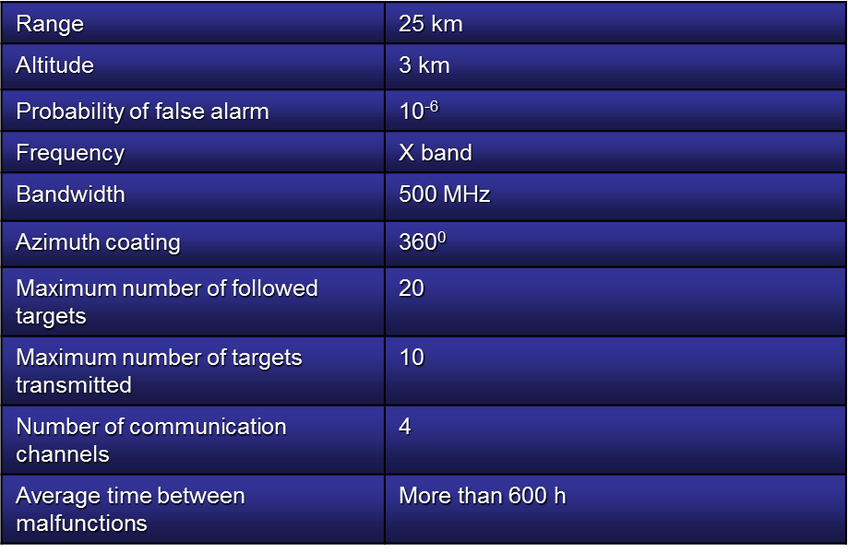1. SHORAR-TCP Radar

2. SHORAR-TCP Container

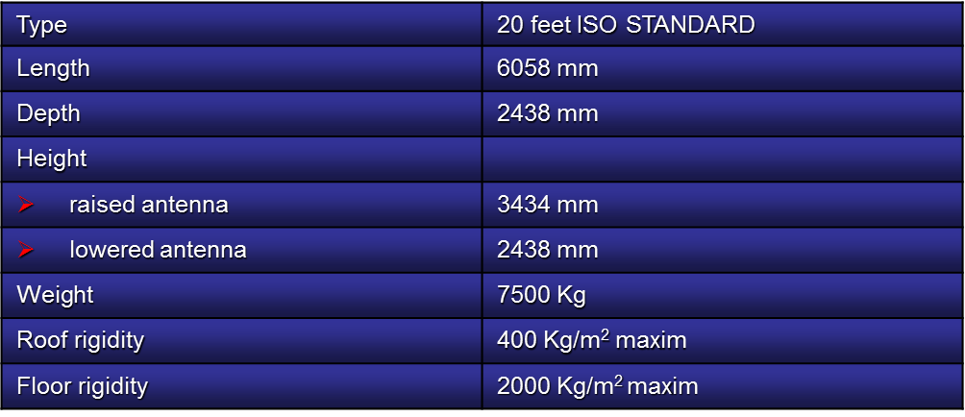

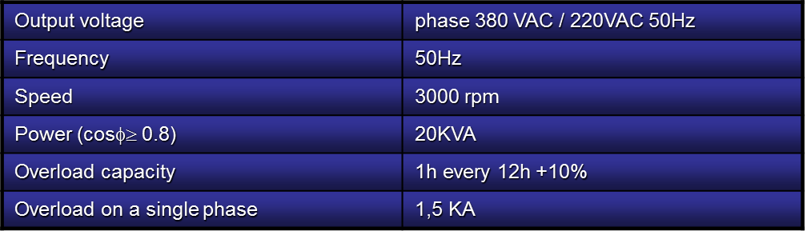3. Generator set

4. Engine

5. Battery unit