**4. Artillery Fire Control System**

***Learning objectives:***

*- explain the basic functions of the Fire Control Unit;*

*- identify and describe the main parts of FCU/GSN;*

*- describe the main requirements for successful battery deployment.*

***4.1. GUN-STAR Night Functions***

Oerlikon Contraves 35 mm air defense system is an automated system designated to protect different objectives (e.g. HQs, air bases). The Oerlikon Contraves system is a complex system, consisting of several automated, interconnected subsystems, which can work centrally (basic mode), but also decentralized.

If the radar (SHORAR-TCP), Gun*Star Night and 35 mm Gun Air Defense System are engaged in a permanent position, according with the Drill Book, a complete reconnaissance needs to be made only once.

Usually the position of Search Radar, Fire Control Units (FCUs), Guns and Power Supply Units (PSUs) is fortified or protected in some way. Also, the ammunition dump, first aid post and quarters can be constructed and perhaps coordinated with the installation of the defended critical asset or vital point. The communication systems can be permanently installed. A typical critical asset of this type is an air-base or a land forces-base. In this case the defense system should be coordinated with the activities of the Air Force or Land Force. A lot of infrastructure can be used by air defense, too.

The Oerlikon Contraves 35 mm air defense system is a complex one (Figure 1). It works in a centralized mode and is mainly composed of:

1. SHORAR TCP - designated for search, detection, identification, and automatic target tracking. The SHORAR has the main role of managing the air space security and optimizing the air targets data to the fire control system Gun*Star Night.

2. Gun*Star Night is an automated subsystem designated to control two cannons. It is based on electro-optical tracking system and equipped with a computer to calculate ballistic trajectory and the timing of the fire release. Fire control system Gun*Star Night (FCU-GSN) provides the following main operations:

a) receives data on air targets at SHORAR TCP or its digital optical sight (DOS);

b) evaluates the potential air attack in the area of responsibility (in decentralized mode);

c) searches, finds and identifies the target;

d) tracking three-dimensional target (finders using laser and electron-optical system);

e) calculates angles of sight for guns;

f) forwards angles in gun sights.

3. Digital Optical Sight (DOS) is operated by a single operator. It is designated to search air targets and send data to GSN. DOS is the main Intel sensor when GSN works in decentralized mode and receives data only from this subsystem.

4. Anti-aircraft automatic guns (AOKs) comprises two 35 mm caliber and are designated to fire directly against air targets or field targets, controlled by GSN or independent.

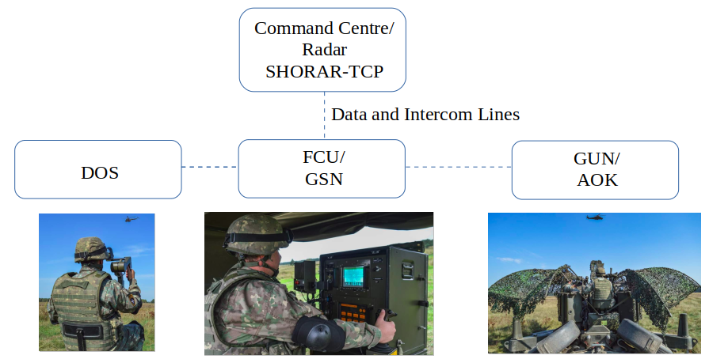

**Fig. 1** The system architecture

***4.2. The Fire Control Unit GUN-STAR Night (GSN/FCU)***

GSN/FCU conducts fire management for each battery consisting of 2x35mm artillery guns (Annex 1). GSN/FCU is a fire management system based on an optoelectronic tracking device and equipped with a ballistics computer for path calculation and fire correction. GSN/FCU is mounted on a small trailer and has an autonomous electrical power group (Figure 2).

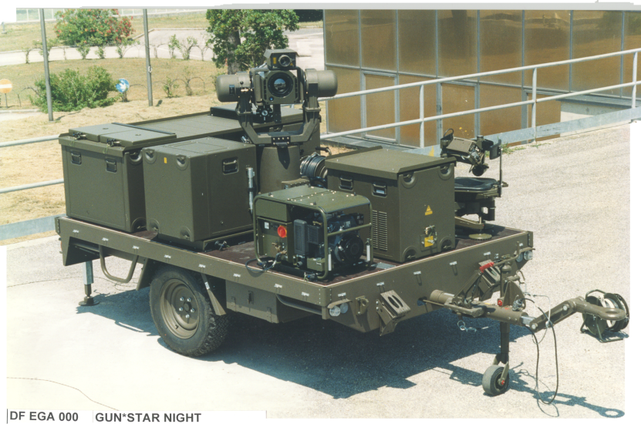

**Fig. 2** GSN/FCU

The main sub-assemblies of the GSN/FCU are:

- Tracker Unit (TU), with laser telemetry and FLIR;

- Data Processing Unit (DPU);

- Tracker Control Unit (TCU);

- Video Processing Unit (VPU);

- Operator control panel unit (OCU);

- Data Processing Unit (DTU);

- Digital optical system (DOS);

- Power Supply Unit (PSU);

- Battery unit (BU);

- Trailer.

**The Tracker Unit (TU), with laser telemetry and FLIR,** is a platform controlled by a group of sensors (FLIR, Laser distance Meter) mounted to achieve target detection, tracking, video playback and telemetry.

The FLIR sensor is capable of detecting small ambient temperature differences relative to a target; this is done by scanning objects that produce a thermal image.

The LASER telemetry is used to measure the distance from the targets that are sensed and followed by the GSN-FCU FLIR Sensor.

**The Data Processing Unit (DPU)** is the central computerized and control system of the FCU GSN.

The DPU, together with a performance software program, performs the following main functions:

- Collect target data via the sensor system;

- Calculate the control data (azimuth and elevation) for the Tracking Unit;

- Calculate the shooting data for the artillery pieces;

- Controls the entire operating system.

DPU, by means of software test and manufacturer's test (Built-In Test / BIT), check all FCU GSN functions.

**The Tracker Control Unit (TCU)** performs the guidance controlof the two axis Tracker Unit.

The TCU performs also the task to send back to the DPU the information concerning the actual values of angular position and angular rate and furthermore the status of the sensors installed on the Tracker Unit and the Tracker Control Unit itself (Figure 3).

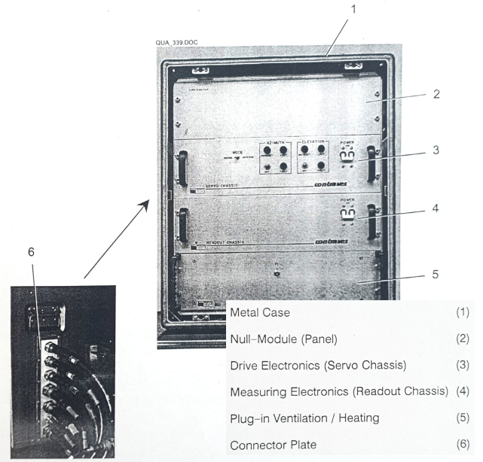

**Fig. 3** TCU (without cover) main parts

**Video Processing Unit (VPU)** processes the analogue composite video signal (CVS) which originates in the FLIR sensor.

The main task is to discern a target in the FLIR field of view and to determine the angular position of the target with respect to the optical axis of the FLIR sensor (Figure 4).

The VPU performes the following functions:

-it distinguishes the target from the FLIR field of vision;

- it determines the angular position of the target, observing the optical axis of the FLIR sensor;

- it evaluates and processes the pixels of the target image representing it in a digital image of the target.

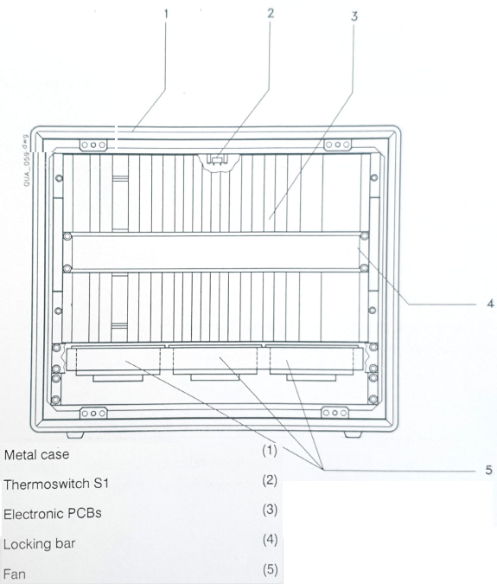

**Fig. 4** Front view of VPU (without cover)

**The Operator Control Unit (OCU)** is contained in a metal box; it can be removed from the transport Trailer in order to operate remotely the GSN/FCU (Figure 5). It is equipped with the following main parts:

- Video Monitor (it reproduces on a screen the image that the FLIR Sensor captures during target tracking and shows some operative parameters to the operator);

- Touch Panel Display (it allows the Operator dealing with the main computer of the GSN/ FCU; the operator can set directly on the screen many different data, and can receive from the computer indications related to the current operations state);

- Joystick (it allows moving the Trucker Mount of an amount proportional to the Joystick deflection);

- Two Intercom stations (provide vocal communication with SHORAR-TCP and vocal communication with Digital Optical Sight and with the 35 mm Guns).

OCU and the software installed perform the following main functions:

- collect input data that the operator can set directly on the screen using the touch Panel Display;

- display of system status indications;

- perform operational movements using the joystick;

- Video Monitor presentation of the image captured by the FLIR Sensor during acquisition and target tracking.

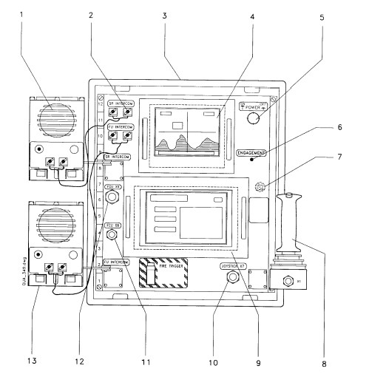

**Fig. 5** Layout of the OCU (front view)

(1) Search Radar Intercom Station; (2) Intercom connector; (3) Operator Control Unit Box;

(4) Video Monitor; (5) Power ON/OFF Pushbutton; (6) ENGAGEMENT Lamp;

(7) Buzzer; (8) Joystick; (9) Touch Panel Display; (10) Connector X7;

(11) Connector X5; (12) Connector X6; (13) FU Intercom Station

**The Data Processing Unit (DTU)** is the central control and computing system of GSN/FCU (Figure 6). The DPU together with the combat program perform the following main tasks within GSN/FCU:

- collecting target data from the system sensors;

- computing the control data (azimuth, elevation) for the Tracker Unit;

- computing the firing data for the weapons;

- controlling all system operations.

The DT-60 interface board allows data exchange between the 35 mm version of the FCU GSN and the 35 mm artillery pieces. The DT-60 is equipped with four synchronous serial channels with two of them used for data communication between the GSN FCU and the artillery pieces. Each serial channel provides a data transmission speed of 2400 bps, two-way.

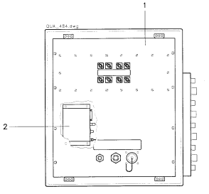

**Fig. 6** Weapon connector panel (rear view)

(1) Weapon Connector Panel 35 mm; (2) Video/ Data Transmission System

**Digital Optical Sight (DOS)** consists of a lower and a rotatable upper mount with the operator’s seat and the adjustable column (Figure 7).The DOS allows easy, fast and highly accurate acquisition of suddenly appearing targets.

It is handled by an operator and is used for aerial surveillance and air designation/acquisition in case of a surprising attack and at a relatively short distance.

The operator can eye a visible target and assign it to the GSN/FCU with the following coordinates:

- angle of the target associated with the physical position of the operator seat;

- target elevation associated with the physical position of the sight-glass arm.

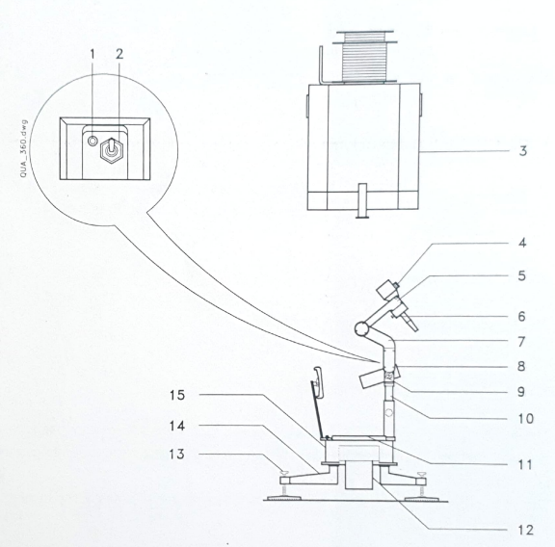

**Fig. 7** Digital Optical Sight (main parts)

(1) LED H1 DOS READY; (2) Toggle switch S2; (3) Covering hood;

(4) Collimator; (5) Swivel arm; (6) Pushbutton S1 DOS ON TARGET;

(7) Bracket; (8) Intercom station; (9) Locking bolt; (10) Adjustable column;

(11) Seat; (12) Support; (13) Spindle; (14) Outrigger; (15) Housing

**Power Supply Unit (PSU)** is supplies the electrical energy required for operation of the FCU (Figure 8). It consists of a gasoline engine with a coupled asynchronous generator. The main technical characteristics are:

-Type: asynchronous, single-phased

- Output voltage: 230 VAC;

- Frequency: 50 Hz;

- Fuel used: unleaded petrol;

- Average consumption: 1,5 l/h.

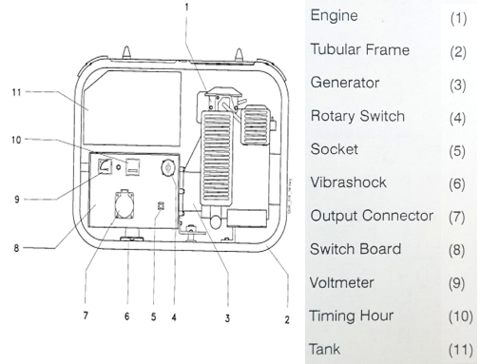

**Fig. 8** Power Supply Unit

**The Battery Unit (BU)** holds four 12 V batteries. The batteries are connected in series to provide the 48 V system voltage.

The battery unit (BU) consists of (Figure 9):

- Battery Charger Unit (BCU) – (1);

- Battery Set (2);

- Power Distribution System (PDS) – (3).

The battery charger unit (BCU) performs the following tasks:

- AC/DC conversion;

- charges the batteries;

- controls the charging process in accordance with of the batteries used;

- optimizes the charging process by controlling the charging voltage depending on the ambient temperature;

- provides five relay outputs to the DPU.

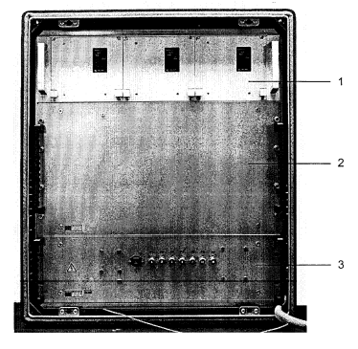

**Fig. 9** Batteries Unit Assemblies

**The trailer** of the GSN-FCU is a commercial type modified and reinforced in according to the military standard. It mainly comprises the carriage, the wheel suspension assembly, the brake system, the lighting system and the flatcar (Figure 10).

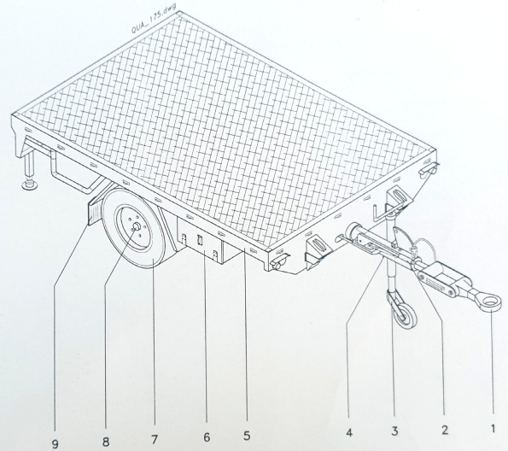

**Fig. 10** Carriage and Wheel Assembly

(1) Towing Eye; (2) Hand Brake; (3) Castor Wheel; (4) Towbar;

(5) Flat Car; (6) Box; (7) Wheel; (8) Wheel Axis; (9) Fender

Annex 1

**Deployment within the anti-aircraft 35 mm battery**

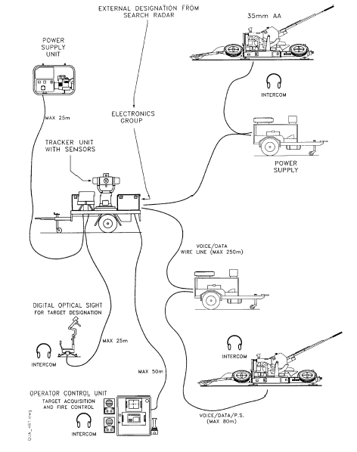

**Deployment within the anti-aircraft 35 mm batallion**

