**10. Romanian Anti-Aircraft Missile Systems**

***Learning objectives:***

*- describe the structure and general operation of SA-7 and SA-9 systems;*

*- identify the factors and subsystems that affecting the design of aerodynamic configurations.*

***10.1. CA-94 (SA-7 ”Grail”)***

CA-94 is used for destruction of the enemy's means of air attack at low altitude and in conditions of direct visibility.

In basic terms, MANPADS system consists of: (1) a missile packaged in a tube which includes a seeker head, (2) a launching mechanism commonly called a “gripstock,” and (3) a battery (Figure 1). Under optimum conditions, an expert operator can assemble, shoulder, and launch a missile in 30 seconds. Most versions are effective against fast-moving targets up to 15,000 +/- feet in altitude and three-to-five miles in range.

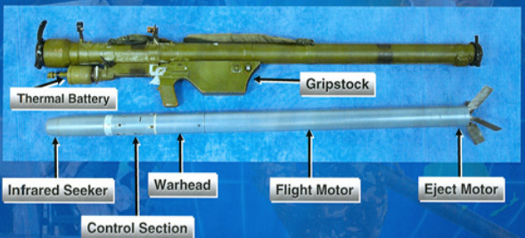

**Fig. 1** MANPADS Components

The main component parts are (Figure 2):

- self-guided missile (1);

- launch mechanism IL-01 (2);

- launch tube IL-02 (3);

- ground power supply BT-A-94 (4).

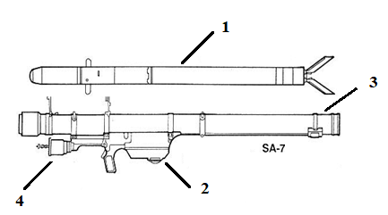

**Fig. 2** CA-94 Components

The on-board missile equipment is made on the principle of single-channel missile control. The essence of the one-way steering method is to control the force in any direction, using a single execution element (a pair of rudders) and rotating the missile around its axis.

The overall operation of the missile shows the complex operation of all its components.

Seeker, passive, thermal, tracking, and narrow-field, automatically accompanies the target and forms the control signal proportional to the angular velocity of the line of sight. It is a gyroscopic tracking system that keeps the coordinator's optical axis in the direction of the target uninterrupted. The autopilot converts the control signals from the electronic block output to the control signals for the rudder rudders.

The rudder compartment is the element that houses the missile flight control equipment and the power supply board. The rudder machine is a gas amplifier of the electrical control signals from seeker, and executes the change of the position of the aerodynamic rudders in the process of missile flight. The GPS supplies the missile's on-board equipment with in-flight power.

The shrapnel, fugitive and cumulative action-packed cargo that destroys aerial targets through shrapnel and shock waves, is initiated by the warhead when the missile meets the target or self-destructs. The warhead is of the electromagnetic type, with a target impact sensor, remote arming and a self-destruct mechanism.

The solid fuel propulsion system launches the missile from the launch tube, imparts a rotational motion to it, accelerates it to an average speed of 500 m/s and keeps it in flight. The starting engine throws the missile from the tube at a speed of 28 m/s and prints a speed around its axis of 20 rpm. After 0.3 sec. In flight, the radiation initiator ensures that the marching engine starts and imparts a speed of 500 m/s to the missile, maintaining it during the flight.

If the missile does not reach the target, after 14-17 s from the launch, the delay ring burns and the electric detonator starts operating, which causes the destruction of the missile.

|  |  |
| --- | --- |
| **STRONG POINTS** | **WEAKNESSES** |
| * easy to handle and transport * high efficiency * light weight * easy to mask * hard to detect | * low efficiency in bad weather * targets evolving limits * lack of proximity warhead * no reconnaissance equipment * sensitive to thermal radiation sources |

***10.2. CA-95 (SA-9 ”Gaskin”)***

The SA-9 Gaskin (Russian name 9K31 Strela-1) is a highly mobile, short-range, low altitude infra-red guided surface-to-air missile system mounted on the wheeled armoured vehicle BRDM-2. The first Strela-1 (SA-9/`Gaskin') launchers were produced in 1966 with the system attaining operational status in 1968.

The CA-95 is intended for the destruction of aircraft, projectiles, light bombs and other low-flying aerial targets. It is used as a means of anti-aircraft defense of land units and subunits and for the direct defense of certain objectives.

The system is based on the BRDM-2 4x4 chassis (Figure 3). The driver and commander are seated in the front and the gunner in the turret. Up to four launch container can be attached to the turret. During travel the missiles are lowered. The system is a stand-alone system, but usually it operates in pairs or groups of four. Target information is relayed by radio by other air defense systems.

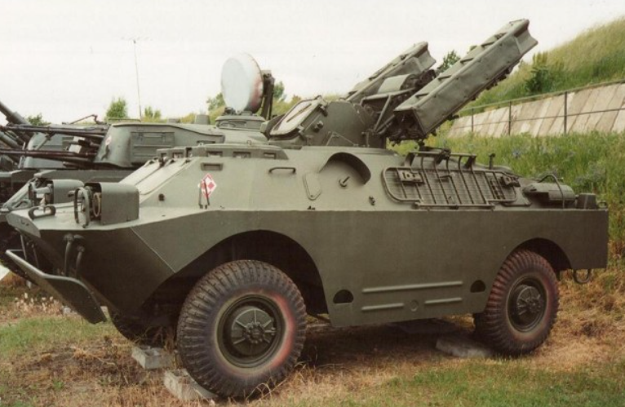

**Fig. 3** SA-9 Gaskin ground-to-air missile

The turret is fitted with four surface to air missiles with infrared guidance. The maximum effective range is 4.2 km and maximum altitude is 3 km. Due to the limitations of the seeker the maximum range can only be achieved under favorable circumstances. Effectiveness during head-on engagements and at night is much reduced.

The steel armor protects from small arms fire and shell splinters. The system is operated under full armor protection, except for reloading the missiles. An NBC system is fitted while smoke grenade dischargers are not.

The main components of CA-95 are:

* **means of combat:**

- ILA-95 firing vehicle;

- anti-aircraft missiles in the container;

* **technical means:**

- IVA-95 verification and control vehicle;

- SPA complete.

* **training means:**

- simulator IA-A 95;

- learning missile.

*Armament:* the system consists of a 9P31 BRDM-2 based Transporter-Erector-Launcher (TEL) with the normal turret and chain-driven belly wheels removed and replaced by a turret with four ready to launch SA-9 container-launcher boxes. Reloading is performed manually and usually takes approximately 5 minutes. The missile boxes are lowered for transport to lower the total height of the vehicle. The driver and commander have periscopes for viewing outside the vehicle when the hatches are closed. The missiles fold down to the sides of the turret which greatly reduces the height of the vehicle whilst travelling.

*Missile:* The original version of the Strela-1 missile was known as the 9M31 (`Gaskin' Mod 0) and used a 9E41 uncooled first-generation lead sulphide (PbS) infra-red seeker operating in the 1 to 3 µm waveband region. This was supplemented by the 9M31M variant (Strela-1M/SA-9b/`Gaskin' Mod 1) which entered service in 1970 and has an improved 9E41 PbS seeker operating in the 1 to 5 µm waveband region to provide greater target sensitivity and lock on ability. When engaging a head-on target the system has a considerably reduced range. The SA-9 is fitted with a 3 kg HE fragmentation warhead and proximity fuze. The warhead has a lethal radius of 5 m and damage radius of 7.6 m.

*Command and control radar*: One SA-9 TEL, usually the battery commander, (SA-9 Mod A, BRDM-2A1 or SA-9A TEL) in each battery has been fitted with 9S16 Flat Box-A. The Flat Box A is a radar detection antenna, one is fitted either side of the hull above the front wheel housings, one under the left launch canisters pointing forward and one mounted on a small frame above the rear engine deck plate pointing rearwards. The azimuth scan sector for the system is 360º, the elevation capability 40º and the maximum detection range 30 km. The BTR-60PU-12 command vehicle of the Strela-1 unit is usually alerted by the Divisional Air Defence Regiment's command post as to a potential target's azimuth, range and altitude. This information is assessed with additional data from the unit's own visual observer network and any microwave transmissions picked up by the Strela-1 `Flat Box' TEL. The commander then instructs the unit as to which target should be engaged by which vehicle and orders the engagement(s) to commence.

*Combat use:* the principle of operation of the CA-95 complex is based on the visual detection of aerial targets and the self-guided missile to the target using the self-steering head.

Upon receipt of the combat command, the operator switches the launcher to the combat position, attempting to visually detect the target. Aiming is done first approximately with the mechanical sight, and then the exact sighting is performed with the sighting device.

After superimposing the reticle of the sighting device with the aerial target, the operator presses the “ACCOMPANY - LAUNCH” button until stage I, operation by which the container box is opened and the aerial target is caught by seeker.

By pressing the “ACCOMPANY - LAUNCH” button until the second stage, the missile launch takes place, after which the operator releases the button and executes a new catch of the air target.

In flight, the missile is powered by the on-board power supply. The target is destroyed by the missile's payload when it hits the air target directly or passes less than 5 m from the target (Figure 4).

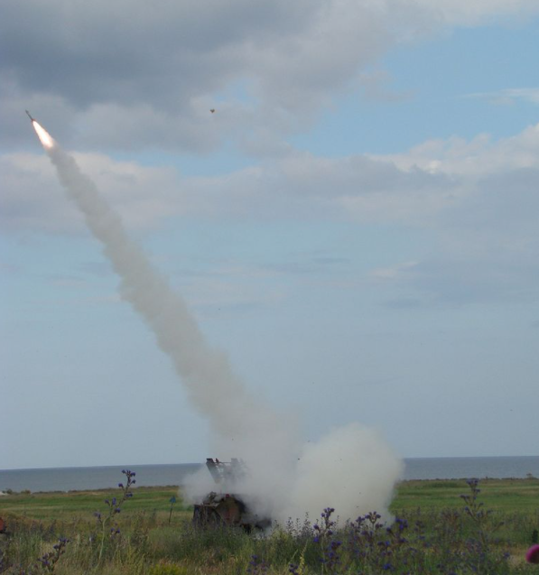

**Fig. 4** Missile Launch

Annex 1

**CA- 94 Basic Technical Data**

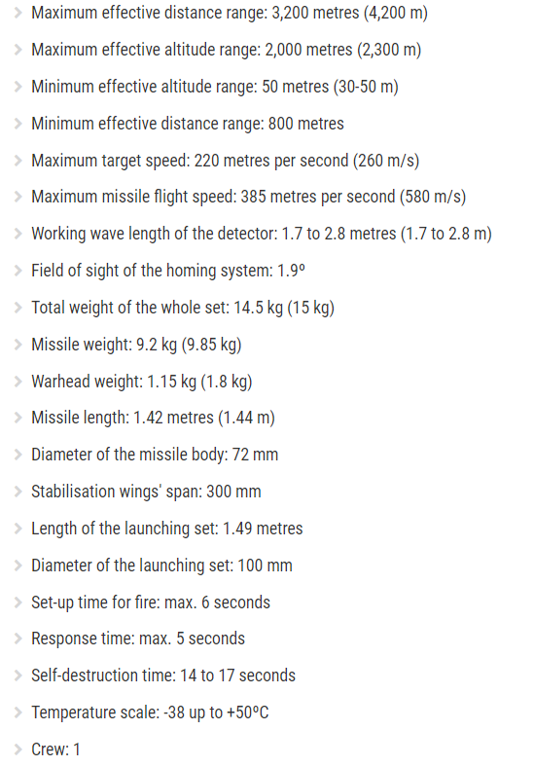

Annex 2

**CA-95 Basic Technical Data**

