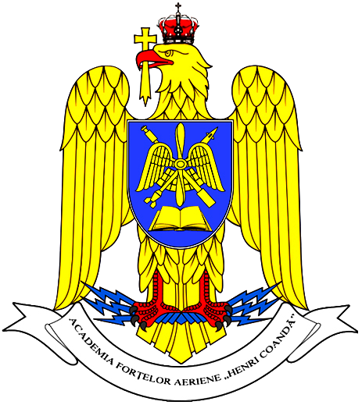
ROMANIA
MINISTRY OF NATIONAL DEFENSE
“Henri Coandă”
AIR FORCE ACADEMY

BRAŞOV, 160, Mihai Viteazu St., Post Code 500183
Tel: +4 0268 423421 Fax: +4 0268 422004
web: www.afahc.ro

INTERNATIONAL WEEK
25 – 29 March, 2019

PARTICIPATION FORM

Please fill in the form and send it by 31th January 2019, to:
- Major Cosmina-Oana ROMAN, PhD, Vice-Rector for Programs and International Relations at „Henri Coandă” Air Force Academy: internationalweek@afahc.ro; cc: roman.cosmina@afahc.ro;

Delegation info:

Country
Academy/Institution
 | ESCORT OFFICER | CADET 1 | CADET 2
First name

Last name

Rank

Gender

Cell phone number, with country code
Personal e-mail address
Passport number and
date of expiry
Food allergy or special diet

TRAVEL PLANS
 | Date | Time |  | Flight/train number | Location/Airport
- Arrival information
- Departure information

Any comment or special request: ……………………………………………………………… …………………………………………………………………………………………….…………………..………………………………………………………………………………………...…………………………………………………………………………………………………………….

