**2. ORGANIZATION AND MISSIONS OF AIR DEFENCE**

***Learning objectives:***

*- analysis of the operational drivers and the technological factors;*

*- identify and describe combat functions for SHORAD organization;*

*- describe the main requirements for successful operations.*

**1. Introduction**

Short range ground-based air defence (GBAD) systems provide an essential defence capability for mobile expeditionary forces and provide the persistence which other air defence elements lack. Today’s forces, however, face not just uncertainty, but capability gaps against the increasingly diverse air threat.

The end of the Cold War has overturned the assumed military imperatives. A threat now needs to be defined as a combination of two elements: Capability and Intent. Existence of one without the other is insufficient to establish a requirement for a capability, and both are subject to potentially rapid change.

For GBAD, new attack technologies, including cruise missiles, unmanned air vehicles, attack helicopters and tactical air-to-surface weapons, plus the ability to obtain such technology off-the-shelf, may provide a first-class capability to any potential aggressor which has the political will to resource it. It is this potential level of Capability which sets the requirements for air defence.

Meanwhile, assessment of intent based on traditional cold-war enmities and groupings has been largely overturned. The proliferation of weapon and sensor technologies, regional instabilities and the ease with which politically unstable countries may obtain near state-of-the-art equipment makes the definition of Intent volatile, changeable and difficult to assess.

Modern means of air attack (MAA) can penetrate a defended air space and territory and destroy high-value economic and defense installations. The primary MAA countermeasures include anti-aircraft weaponry sets (AAW). AAW form a critical component of any air defense system used to protect strategic discrete and area installations. AAW can be deployed as short-range air defense (SHORAD) and very short-range air defense (VSHORAD) systems around strategic installations.

A VSHORAD system usually features the following components:

- anti-aircraft missile and artillery (AAMA) sets;

- short-range radar unit;

- air defense system control unit, which exchanges data with a superordinate air defense command system.

This approach assumes that an air defense system control post has been connected to a national air defense system. This means that the control post should receive:

- recognized air picture for the region and the approach directions for the protected area;

- air defense plans from a superordinate air defense command system unit.

Air defense systems based on AAMA sets can be effectively used at the stage of repelling air attacks and effectively defending a protected installation, assuming that the VSHORAD deployment is properly located at the air defense deployment planning stage. Air defense deployment planning is a process which requires the consideration of many factors. These factors include: terrain properties which may affect the local radar unit’s detection zone, and the VSHORAD kill zones.

In the process of planning AAMA set deployment, many highly uncertain factors exist, including the uncertainty of (i) enemy MAA type, (ii) enemy MAA ordinance, (iii) enemy air raid composition, (iv) enemy MAA flight trajectory, (v) enemy MAA tactics, (vi) enemy reconnaissance of the protected area, and much more. It was thus decided to assume simplified models for the VSHORAD and the local radar’s identification zones.

Other and no less important factors which affect the operating capabilities of VSHORAD systems include the quality of the WTA methods for the individual AAMA sets and the AAMA set fire control methods.

The top-down approach is used to postulate operational concepts and system architectures (Fig. 2-1). The process follows the classic thesis, synthesis, antithesis approach whereby concepts are proposed either top-down or bottom up, synthesised in a system context and then tested in a range of operational scenarios to provide a basis for further concept development.

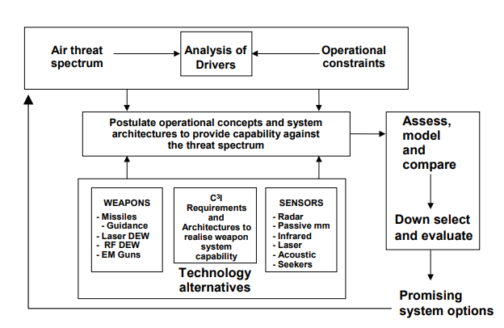

Fig. 2-1 Overview of conceptual approach

The first stage is to assess the developing threat and the operational conditions, which includes predictions of air threat technology advances and technology counters at the system and sub-system levels. The operational implications of this interaction are extrapolated into an assumed military doctrine relevant to the timeframe, that is developed through a combination of user experience and assessment against the principles of war. The general perception tends to be that the Revolution in Military Affairs is more evolution than revolution, and although the rapidity of change provides great challenges, none of the new conditions are striking at the fundamental principles of war. In an uncertain and volatile future, these principles are held to provide the most robust framework for assessing potential system concepts.

Performance against each element of the derived threat array is assessed at a system level. No single threat element (eg., the ballistic missile) is allowed to dominate the concept development process, although the operational drivers (eg., non-line-of-sight helicopters) will carry more weight. The aim is for a flexible and balanced concept which has an assessed capability against the broad range of potential threats. This reflects both the reality of uncertainty and the need for capability in a wide range of circumstances. This process is iterative and results in a gradually-refined concept which is relevant for the timeframe.

**2. The developing operational context**

Analysis of the new spectrum of conflict indicates that forces must be trained and equipped for full warfighting in order to be in a position to discharge properly peace support functions. Similarly, it is generally accepted that materiel designed for “high intensity” operations, operated with extreme competence, is the best way to deter conflict at any level.

In a classic warfighting scenario, there are broadly two aspects on which to base an assessment: the diverse threat stream expected in the future; and the operational realities of the battlespace. The former includes specific target types, numbers and profiles, and may include multiple simultaneous threats. The latter involves the need to be able to move, survive and fight on the battlefield without compromising operational security.

In a peace support context short of warfighting, additional imperatives need to be taken into account. The manoeuvrist approach puts an emphasis on the OODA (Observation, Orientation, Decision, Action) loop, and the use and deployment of information to get inside the decision loop of the enemy, so as to surprise him, or to challenge him with conditions to which he is unable to produce a timely response. The development of information warfare at the geo-strategic level, and its application as command and control warfare at the operational level, will place additional demands upon the supply, interpretation and exploitation of information.

It seems inevitable, therefore, that in order to keep inside the decision loop of the enemy, be this in terms of conventional or asymmetric warfare, there will need to be an increasing emphasis on information-gathering sensor-based systems. The need for increased situational awareness is assessed to make weapons subsidiary in importance to the surveillance and sensor function.

An illustration of the assumed process is given at Figure 2-2, which suggests that sensor needs will dominate as firepower-based system considerations decline.

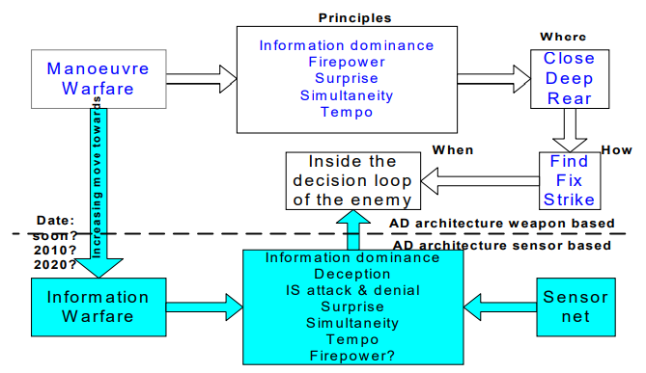

Fig. 2-2 Assumed doctrine development

Information itself may supplant some aspects of firepower, although an effective kill mechanism will remain an essential part of the overall system. Sensors are likely to become more generic and less tied to AD weapon platforms. Political control will be an increasingly-important factor in all military operational planning, and there is already an emphasis on the avoidance of casualties, particularly of civilians and neutrals. Commitment of forces is likely to involve a stated or assumed moral dimension. In particular the avoidance of civilian and neutral casualties will outweigh any operational risks incurred by following this policy, at least until action is joined and the first casualties taken. This trend is already apparent in NATO rules of engagement which suggest that no target should be engaged unless it has been observed committing a hostile act or has been declared hostile.

This projected future is illustrated by the influence diagram at Figure 2-3. Lines indicate influences on actions, with plus signs indicating a positive relationship, and minus signs the inverse.

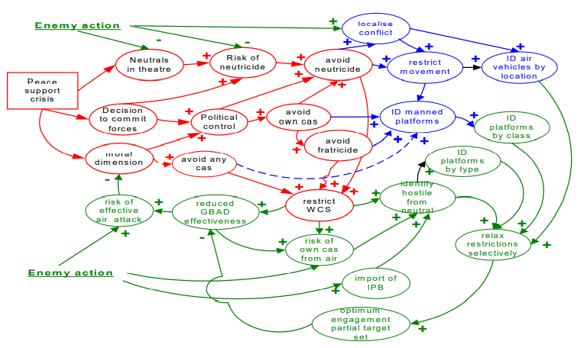

Fig. 2-3 Influence diagram for air target information requirements

The evaluation represented here suggests that all influences in a non-warfighting situation will tend to exacerbate the current requirement for severely-restrictive weapon controls. In the future, this may manifest itself as restrictively high identification thresholds from the identification data fusion process.

Only if enemy action occurs, and casualties are suffered, will the moral imperatives diminish and the need for more effective GBAD act as a counterweight to the restrictions on operations. The need to maintain control in the battlespace, and the continuing political imperatives to avoid friendly and neutral casualties will increase the importance of obtaining air target identification information to assist this process. This additional data may be used to segment the target set so that priorities and comparative risk assessment can allow relaxation in weapon control status, or in identification threshold levels. This will allow the increasing proportion of the target set which is unmanned to be engaged without increasing the fratricide risk for manned platforms.

**3. The “Zone concept”**

However, some of these combinations may be mutually exclusive, or at best highly unlikely. To help maintain a balanced view of all the factors, a focusing framework has been developed with the main factors illustrated in Figure 2-4. The resultant “Zone concept” is based upon the principle that the air threat to ground-based forces will tend to be a function of the nature of the ground-based asset itself, which will, inter alia, depend on its function and importance, its location on the battlefield, the time or stage of the battle, and perhaps most importantly, the ease of targeting - which includes consideration of its “visibility” to electronic and visual systems, its mobility and the “five S’s”s (size, shadow, shape, shine, silhouette). Other factors include the value and level of protection of the target. The former will depend upon its inherent battlewinning performance, or political sensitivity, relative scarcity and the time/stage of the battle, whereas the latter will tend to depend on its mobility, “hardness”, size/layout and posture, location on the battlefield, terrain, and signature. Finally, the vulnerability, survivability, numbers, technological sophistication, level of training, culture etc. of the attacker must be taken into account.

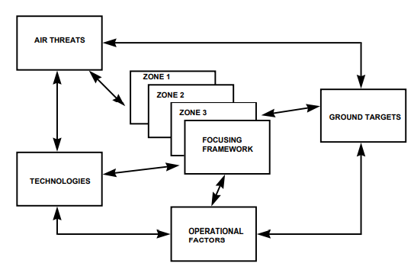

Fig. 2-4 Zone concept as a focusing framework

The vulnerability relationship of the defended asset itself may be complex, especially for manoeuvre elements, as illustrated in Table 2-1. This shows the inherent vulnerability of combat elements to attack, the least vulnerable being on the right. Although for completeness the defended asset characteristics shown in Table 2-1 are based upon a conventional armoured formation, and implicitly at divisional level or above, they could also apply at lower levels of force commitment and of equipment capability. A broad summary of the most likely targets to be seen over the battlefield is given at Table 2-2, which attempts to “Zone” categories of hostile air targets by broadly relating these to targets to be defended by friendly AD.

Tab. 2-1 Combat asset vulnerability

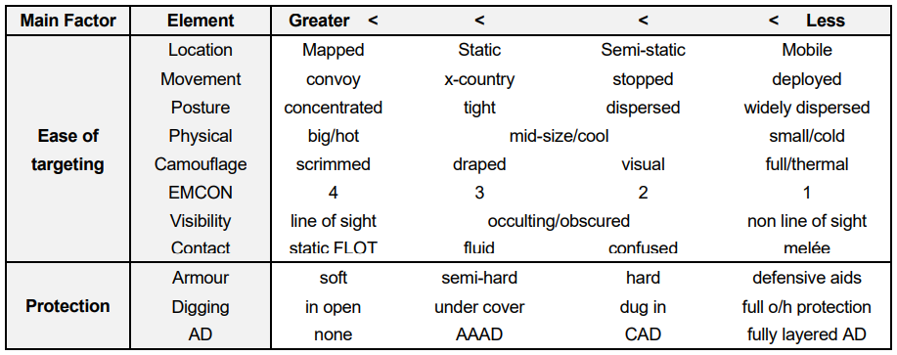

Tab. 2-2 Target and asset distribution

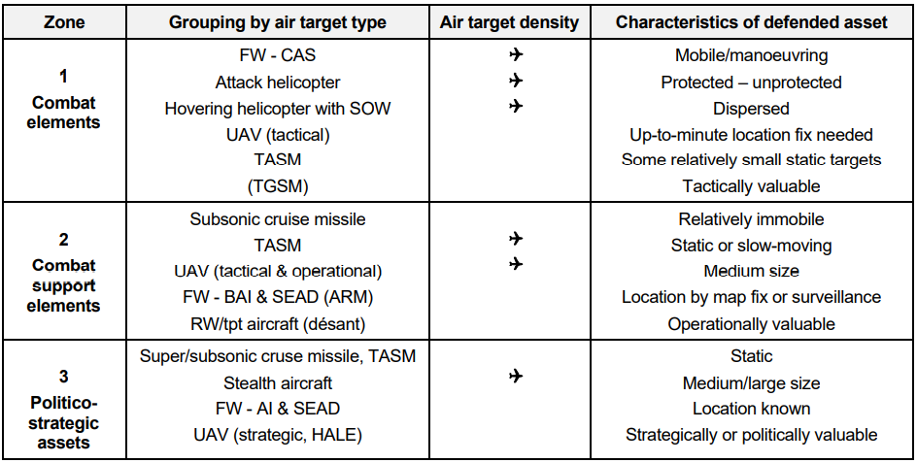

The degree to which an enemy might possess capability in all these threat categories would depend on the individual scenario. The descriptor “Zone concept” does not imply a linear battlefield, but recognises the fact that combat assets tend to group together, and strategic level assets tend to be located relatively far from the combat zone, although this is by no means always the case, especially in peace support operations where “enclaves” may be a major characteristic.

Analysis of asset deployment over time has suggested that the broad groupings indicated in Table 2-2 overleaf will remain broadly valid over a wide range of scenarios. With minor changes, these groupings have been the basis for all future systems studies.

The design drivers for AD weapon systems are likely to change largely as a result of the characteristics of the targets to be defended and the factors already stated. The characteristics of an AD system for defence of manoeuvre units in contact will be notably different from that for defence of an operational level asset such as a Sea or Air Port of Disembarkation (SPOD, APOD).

It is mainly operational issues which delineate the Zone 1 requirements from those of Zone 2, which are broadly threat driven. The Zone 1 AD element has to be able to provide air defence for highly mobile operations on a dispersed battlefield, whilst surviving and maintaining operational security. As the all-weather and through-cloud threat increases this will create a requirement for active systems that will compromise security and survivability. The greatest threat in the latter context is artillery, so active systems must have low probability of intercept and their concept of operations must be difficult to template. A crossing target capability against the Zone 1 threat stream is necessary to free the AD system concept from the need to collocate with defended assets and to enhance security. The advantages of being able to separate the sensor function and weapon functions so as to be able to optimise each without compromising the other, and to exploit the geometry of the battlefield to allow more survivable deployments, becomes very attractive. Such distributed system concepts also allow more radical approaches to the support of moving assets than allowed by concepts which depend on weapon systems collocated with sensors. The greatest technical threat in this Zone is the non-line-of-sight (NLOS) helicopter. The greatest system drivers are this NLOS requirement and the short timelines associated with late-unmasking targets, coupled with the need to be able to satisfy the engagement criteria without the restrictions implied by a requirement for the visual recognition of targets.

Zone 2 is characterised by the most technologically sophisticated and diverse threat with the main drivers being the stealthy small target and the steeply-diving TASM, coupled with a need to be able to match the arrival rate of a multiple and multi-directional threat. Situational awareness, with its implicit benefits for air target identification, and the maintenance of an efficient sensor net in the presence of the most severe countermeasures, are also fundamental to timely and effective engagement.

An all-pervasive driver which is particularly important in a crisis reaction force context, is the need for adequate air target information which will allow effective engagement of the more stressing target set whilst holding fratricide risk, particularly of manned platforms, to an acceptably low level. An assessment of the most important AD drivers derived from this process is shown in Table 2-3.

Tab. 2-3 Emergent AD concept drivers

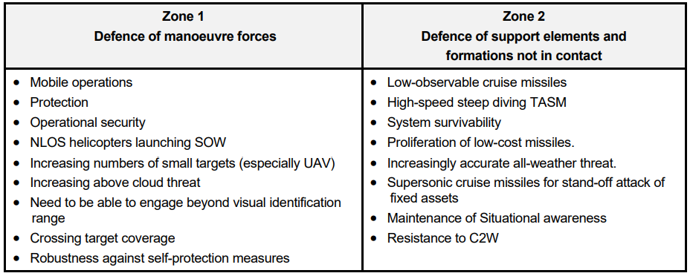

**4. Technology alternatives and architectures**

The areas within which it is necessary to consider technology alternatives to populate system and sub-system architecture proposals, consist of weapons, sensors and C3I. Within these areas there will be other considerations such as multi-function possibilities and fusion of information at various levels. The linkage of technology alternatives with the discussion of emergent AD concept drivers is through a general statement of requirements as exemplified in Table 2-4. The broad requirements have been stated without reference to Zone and there will be detailed trade-offs between system requirements, capabilities and implementation when the operational aspects of Zones are considered. The driving aim, however, is to keep in mind the potential for modularity at the architecture, technology and functional levels to achieve a robust AD system to meet the operational requirements identified through the Zone concept focusing framework.

Tab. 2-4 Required broad AD system characteristics

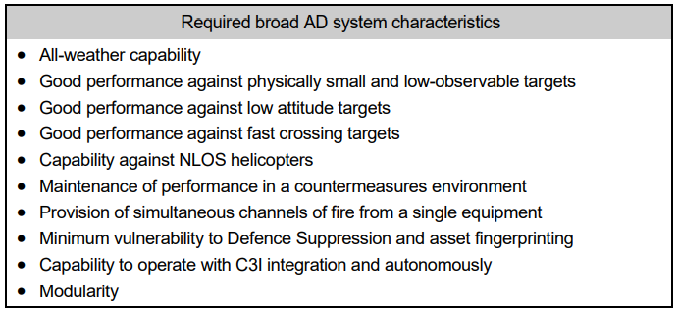

Whereas many features of Table 2-4 can be identified as germane to current AD missile systems, results from Operational Analysis and lethality studies have shown that for a future AD system:

- the forecast threat will require a significant increase in lethality compared to current systems;

- a capability against air-launched missiles will be essential;

- engagement ranges, against agile and fast crossing targets, greater than 7-8 km are highly desirable to minimise the regime where neither threat launch platform nor threat munitions can be engaged. It should be noted that the most up to date, authoritative reference on engagement range requirements is extant in the latest NATO Staff Requirement for VSHORADS/SHORADS ;

- the most demanding target detection requirements are set by those targets which operate at very low altitude, by missiles with high, terminal dive angles, and by the very fast LO missile target;

- a capability to provide multiple, simultaneous fire channels from a single equipment will greatly improve resistance to saturation attack from stand-off missiles;

- a NLOS capability will be essential for the defeat of attack helicopters, and improved system effectiveness against both missile and fixed wing threats;

- the ability to site sensors and launchers remotely from each other can enhance system performance, particularly against small cross section targets at very low altitude, and confer other benefits of operational security, survivability and flexibility.

**5. Combat functions**

Combat functions shall be the principal instruments at the disposal of the commander, which the commander shall integrate and coordinate in the operation, in order to synchronize their effects over time, space and purpose.

Combat functions are: information; maneuver; anti-aircraft defense; fire support; mobility and protection; logistics; command and control.

AD, as a combat function within the area of responsibility of the interarms unit, shall cover its forces and means against attack and aerial surveillance of the enemy and shall cover all active and passive activities and measures executed with a view to nullifying/rejecting or reducing the effectiveness of the actions of unmanned aircraft, missiles and aircraft.

The firing missile platoon is a ***sub-unit type structure*** that acts within the battery or independently.

When acting independently, the anti-aircraft rocket platoon is the basic tactical sub-unit and can be found in the composition of the battalion: parachute infantry, mountain hunters, tanks, genius, passes, and masking.

In certain situations, anti-aircraft rocket platoons in the battery of anti-aircraft rockets can act directly in support of an interarms unit/sub-unit.

The firing artillery platoon is a ***firing sub-unit type structure***, which acts within the battery.

In certain situations, the firing artillery platoon can act directly in support of interarms units/sub-units.

The missile group is the ***firing unit or with other destinations*** that are in the composition of the independent firing missile platoon or the launch pad in the organic battery.

The artillery group is a ***firing unit type structure or other destinations*** found in the composition of the firing artillery platoon or batteries data insurance, servicing, technical maintenance.

AD structures operating in the area of the interarms force group contribute to its support operations by countering the recognition, surveillance and acquisition of targets (RSAT) executed by the air enemy in particular with helicopters.

The use of the platoon/group in the advanced area of AD determines the freedom of maneuver of the supported forces during operations.

With high firing rate, very high reaction and high precision AD systems, the platoon is involved in the fight against aircraft, helicopters, unmanned aerial vehicles and cruise missiles (CMS) within the fire area and depending on the terrain characteristics.

The firing artillery platoon participates in combating land enemy for self-defense purposes by firing on uncovered, fixed or mobile targets on the ground or on the surface of the water, in all weather conditions, with the aim of achieving the effects of destruction, neutralization, prohibition and harassment.

***The organization*** of firing missiles/ artillery platoons within the ground forces differs depending on the structures in which they operate and the type of technique.

In principle, independent firing missiles and launch platoons within the battery are in composition with the float control and 2 ÷ 3 release groups.

The control platoons typically include the automated point of control of the battery/regiment and research, transmission and topographic groups.

The firing artillery platoons have in composition the platoon control and 2 ÷ 4 firing groups, depending on the technique related to the structure.

The firing launching/firing missile groups compose 1 ÷ 3 launching installations/mechanisms, depending on the sub-unit to which it belongs and the type of technique to which it is fitted.

The groups within firing missiles/ artillery systems with other destinations - research, automated command point, rocket transport, missile functional tests, firing command post, data processing and reception system - are in the composition of the battery/ platoon and have the task of providing information with specific and logistical data on missiles and ammunition is to provide the firing sub-units.

The firing artillery group consists of: group commander; a variable number of servants, depending on the type of technique equipped; a driver/driver.

As well as organization, ***the equipment*** of firing missile/ artillery sub-units is determined by their structure, the type of basic technique and the specific equipment standards.

In principle, the provision of firing missile sub-units refers to: combat machines; launch facilities/ mechanisms; automated driving points; communication means; individual infantry weapons; nuclear, biological and chemical (NBC) protective aids.

Generally, the equipment of AD units consists of: machine guns, towed guns, ground to air firing systems, targeting systems, towing means, means of communication, infantry weapons, means of NBC protection, means of camouflage and engineering tools.

Going by the technical characteristics of range and height, AD guns are classified in:

a) Very Short Range Air Defences – VSHORAD

b) Short Range Air Defences – SHORAD

c) High and Medium Air Defences – HIMAD

***The mission*** of the AD platoon or group is to take the fight to the enemy air threat to defend and cover friendly forces, within their means, typically within the battery, but can do so independently, too.

For the success of this mission, the platoon has the ***tasks and objectives***:

a) Prepares the defense against enemy surveillance and air attacks, in their assigned area;

b) Determines the tactical evolution of air platforms bearing in mind the technical capabilities of the given ordonance;

c) Destroys air platforms utilizing own fire systems;

d) Bans the use of air space by the enemy in their assigned area;

The mission and tasks of the platoon in air defense as a function of combat depend on: the importance of air defense forces; the characteristics and possibilities of the given technique; the means of attacking the enemy's air means; the conditions for the execution of operations and are expressed through standard tactical missions, determined by the nature of the support relations between the anti-aircraft missile or anti-aircraft artillery units and the large joint units.

***The objectives of anti-aircraft defense*** are the elements of the combat unit of the joint unit and the obligatory crossing points.

For the use of a common language in air defense, ***the heights are classified*** as follows:

a) Very small: up to 150 m (500 ft.);

b) Small: between 150 ÷ 1,500 m (500 ÷ 5,000 ft.);

c) Average: between 1,500 ÷ 7,500 m (5,000 ÷ 25,000 ft.);

d) Large: between 7,500 ÷ 15,000 m (25,000 ÷ 50,000 ft.);

e) Stratospheric: over 15,000 m (50,000 ft.).

***Requirements for successful operations***

The commander of the platoon, anti-aircraft missile, and anti-aircraft artillery group must know and apply, in order to achieve success in combat, the following ***general requirements***: initiative; agility; depth; multilateralism; synchronization.

*1. The initiative*

***The initiative***, in on-going operations, keeps or changes the parameters /terms of the fight and assumes an aggressive/offensive spirit during the operations.

The initiative requires the leader to anticipate the course of the air enemy's operation so that the unit can act independently in support of the commander's intent to accomplish the mission.

Platoons and groups must be able to counter the operations of the enemy air forces, in order to stop them, before they can have a negative influence on friendly forces, by planning operations and organizing means of fire and forces.

*2. Agility*

***Agility*** is the ability of one's own forces to react faster than the enemy to gain and maintain initiative.

For platoons and groups, agility supposes the ability to adjust or resize their anti-aircraft cover in order to effectively discover and combat enemy air means.

Platoon and group commanders can draw up a sketch of the enemy's mode of action to use in contour the decision support model, which is a procedure adopted to achieve the agility necessary for a rapid concentration or distribution of anti-aircraft fire.

*3. Depth*

***Depth*** implies the extension in time, space, resources and purposes of the operation. This is the ability to obtain information and influence operations in all fields of the battlefield.

The depth of the operations of the platoon or group is determined by the technical and tactical characteristics of the weapon used - banks of anti-aircraft missiles/machine guns/cannons/anti-aircraft systems - and of the means of uncovering by radiolocation within the fire control groups.

*4. Multilateralism*

***Multilateralism*** is the ability to meet the requirements of different types of missions. The platoon or group must be flexible in operation in order to be able to support the operational units and subunits.

Multilateralism can be the capacity to move quickly from the AD support of the defense operation to the anti-aircraft support of the offensive operation.

*5. Synchronization*

***Synchronization*** is the framing of operations in time and space, in order to concentrate fighting effort against the air enemy in the decisive points. This implies a clear understanding, by the platoon or group commander, of the intention of the battery or unit commander being supported.

The platoon or group achieves synchronization by concentrating anti-aircraft fire at critical points during combat.

The synchronization of platoon or group operations can be represented by maneuvering and putting up firing and research means in the tactical field, according to the intention of the commander of the battery and upper echelon, in order to destroy or neutralize any aerial action, within the fire possibilities of the equipment.